Iiiiliilmnilniliiiiliiilmliiiiliiilllntlmlilimiiili

*************************3~DIGIT Breek H Camp CML 12/99 PO Box 47070 Atlanta GA 30362-0070

hmi vnivniAiw -in QuiiiAiQMnm rmvnnQQv iwi -in Mniiwm~mnri nwMmimi wnh

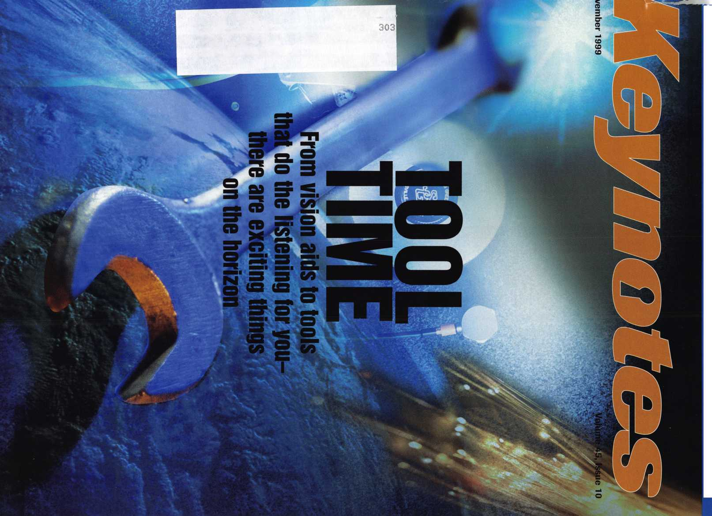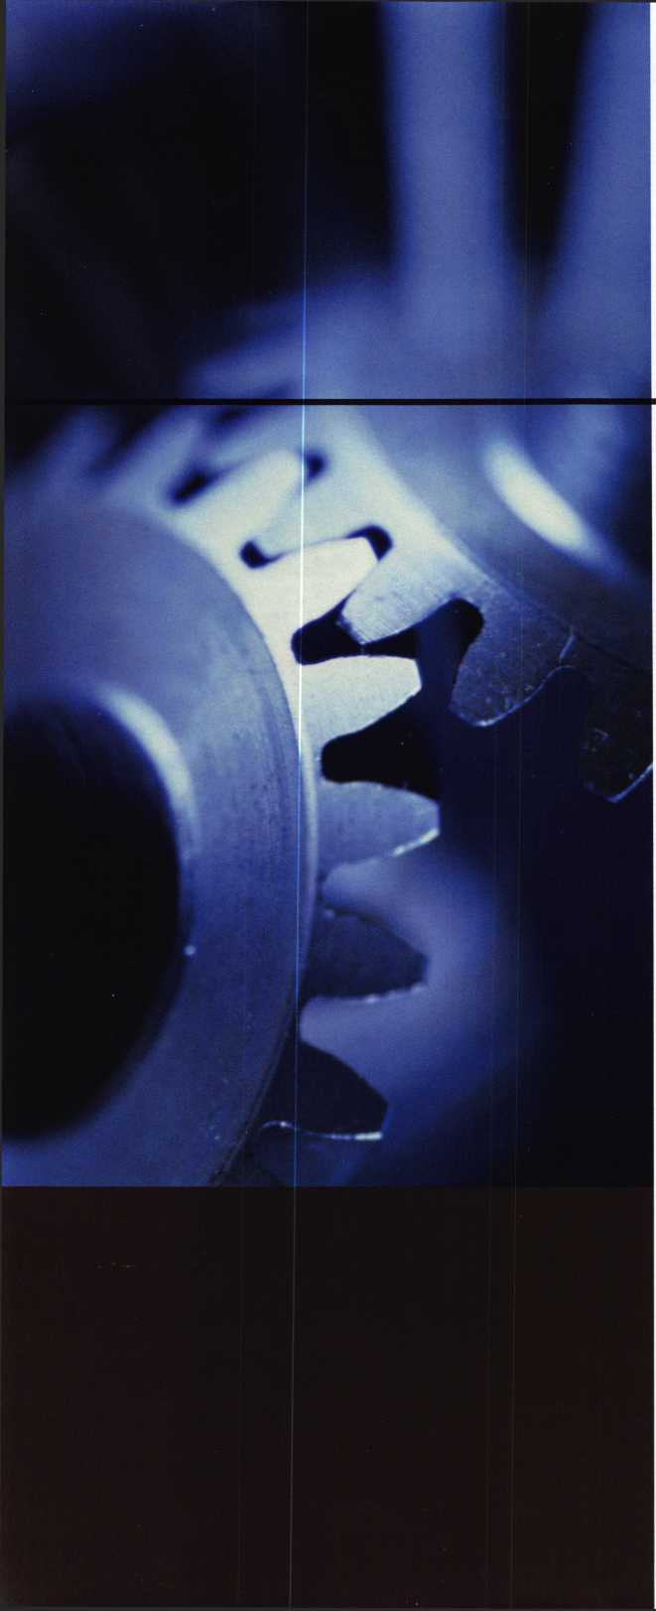

Heavy Metal.

Safe and vault technicians are not strangers to the concept of how to make large metal objects rock and roll. So what better place to hold the last safe and vault trade show of the millennium than The Steel City-Birmingham, Alabama?

From manufacturers7 seminars, to education, to demonstrations and more, **SAFETECH2000** is your best opportunity to prepare yourself for your future.

While you're there you can enjoy the city known for its industriousness, as well as good ol7 Southern hospitality. Tour the Sloss Furnaces, the Mercedes Benz factory or any of a number of museums. You can also explore the richly wooded foothills and mysterious caverns of the Appalachian Mountains.

Join us May 1 through 6 and we're sure you'll agree-Birmingham, and **SAFETECH2000** rock

For more information call

**214.827.7233,**

or visit our website at

[www.savta.org](http://www.savta.org)



**SAFETECH2000**WE'VE GOT **THE WORKS**



BAG



AIR



If you don’t want  
an air bag popping up  
all of a sudden and ruining  
your day, then this Guide  
from Mitchell is for you.

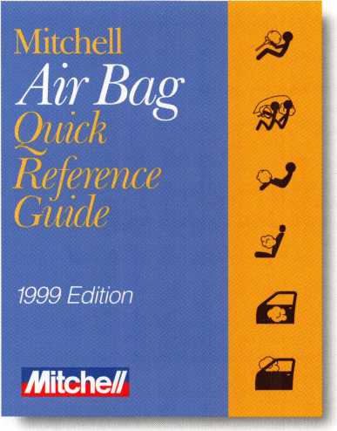

When you’re working around air bags, there is no substitute for the • Complete, easy-to-read “CAUTIONS” to prevent accidental

specific model’s most up-to-date air bag information. Accidental air bag deployments.

deployments are expensive and dangerous, and this is the Guide that • Specific Year, System, Model articles.

can save you from sudden disasters. This Air Bag Quick Reference • Air bag component location.

Guide from Mitchell features: • Special introductory price of $49.95* (regular price is $75.00)

To order or for more information, call

1 800 238-9111, ext. 4070

*Call today, because the special offer of $49.95 expires December 31,1999!

Mitche//

Contents

November

99

Features

4

President’s Journey

By John J. Greenan, CML, CPS

14

Buiiding An Ownership Culture in Your Business

How to make your employees feel even more like team players.

By Claire Cohen, CML

15

Around - Unraveling the Weiserbolt

An interesting lock but there’s more than meets the eye.

By Sal Dulcamara, CML

19

New Tool for a New Era

Step into the future with Mas-Hamilton’s Soft Drill!

By Don B. Dennis, CPL

22

Strattec 2000

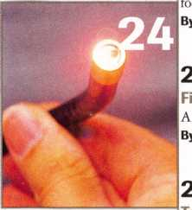

Y2K is closing in on us. Are you ready

the changes Strattec has to offer?

Sal Dulcamara, CML

!4

her Optic Inspection Tool

new tool that can benefit all locksmiths.

**f** Sal Dulcamro, CML

!8

tools of the Trade

Starting out in the locksmith business can be quite expensive. Our author reviews the necessary tools to begin with and how each will impact your business.

By C.D. Lipscomb, CML

30

Legislative Update

Is it a crime to mail locksmithing devices?

Our legislative expert has the low down, plus plenty of updates from around the country.

By Tim McMullen

Upcoming Events

Security Marketplace

36

Associate Members

39

Ad Index

33

Classifieds

**Volume 45, Issue 10**

**Departments**

Core

Group 4 goes to the Pentagon. A new Radionics product is recognized as one of industry’s finest.

Applicants for Membership

Scheduled for clearance Dec. 1

42

Authors in This Issue

44

Back Page

The Cover

This issue, we look at a variety of tools & how they help you on the job.

Art direction/design Valerie Rowe

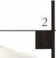

Keynotes

November 1999

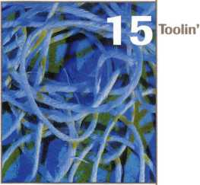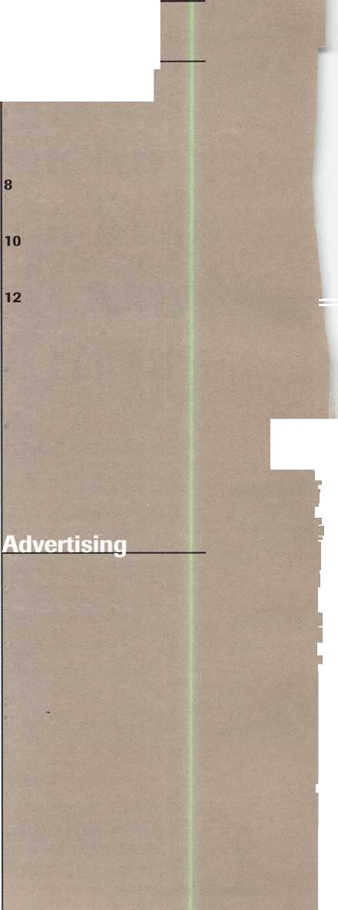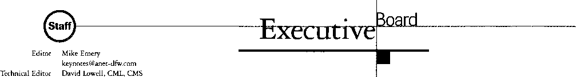

Communications/Financial Coordinator Editorial Advisor

Advertising Sales

Contributing Editors

Contributing Authors

[david@aloa.ioffice.com](mailto:david@aloa.ioffice.com)

Patanya Johnson

John D. Cannon, CML

[jdcannon@worldnet.att.net](mailto:jdcannon@worldnet.att.net)

Marvin Diamond

Native American Journal Co.

(706) 782-0878

[thediamonds@mindspring.com](mailto:thediamonds@mindspring.com)

Paul Chandler, CRL

Claire Cohen, CML

Sal Dulcamaro, CML

Jerome V. Andrews, CML

Brian Costley, CML, CMS

Bob De Weese, CPL

Ray D’Adamo, CML

Michael A. Ferrill

James Glazier, CML

Daniel Graffeo, CRL, CMS

Wayne Gurnee, CRL

A.J. Hoffman, CML

Ken Holmlund, CRL

Ray Lusk, CML

Mark Ohno

Randy Simpson, CML

Robert Stafford, CPL

Dave Thielen, CML

Additional contact information for the ALOA Board and most Keynotes authors is available through “Locksmith Search”’ on the ALOA website- [www.aloa.org](http://www.aloa.org) or by contacting the ALOA office at 3003 Live Oak Street; Dallas, TX 75204; 0800)532-2562;

FAX (214J827-1810; e-mail [aloa@aloa.org](mailto:aloa@aloa.org).

President

John J. Greenan, CML, CPS (773) 486-2030

Secretary

John D. Cannon. CML (703) 960-6413

Directors, Northeast

James H. Glazier, CML (301) 831-5454 John C. Magee, III

1. 845-3434 William L. Young, CML
2. ) 647-5042

Directors, Southeast

Thomas W. Tate (850) 476-4211 Donald E. Rule, CML (601) 324-2658

Directors, North Central

Mark E. Blum, CML, CPS (517) 482-5809 Tom Ripp, CRL (608) 262-3831

Director, South Central

Randy L. Simpson, CML (713) 780-7026

ALOA Professional Staff

|  |  |  |
| --- | --- | --- |
| Executive Director | Charles W. Gibson, Jr., CAE [charlie@aloa.ioffice.com](mailto:charlie@aloa.ioffice.com) |  |
| Operations Manager | Mary May  [mary@aloa.ioffice.com](mailto:mary@aloa.ioffice.com) |  |
| Comptroller | Kathy J. Romo |  |
| Meetings Manager | Jessica Smith [jessica@aloa.ioffice.com](mailto:jessica@aloa.ioffice.com) |  |
| Meetings Assistant | Amy Sheffield |  |
| Government Affairs Manager | Tim McMullen  [tim@aloa.ioffice.com](mailto:tim@aloa.ioffice.com) |  |
| PRP/Education Manager | David Lowell, CML, CMS [david@aloa.ioffice.com](mailto:david@aloa.ioffice.com) |  |
| PRP/Education Coordinator | Ashley Spencer |  |
| Membership Manager Chapters & Regional | Mike Ferrill |  |
| Associations Liaison | Tim McMullen [tim@aloa.ioffice.com](mailto:tim@aloa.ioffice.com) |  |
| Information Systems Manager | Randy McChristian |  |
| Mailroom Assistant | Mike Harrison |  |
| Receptionist | Barbara Ortiz | w |

Directors, Southwest

Gordon R. Racine, CML (719) 384-4707 John A. IIK CRL (602) 420-2174

Director, Northwest

Scott L. Henke, CRL, CPS (907) 248-3785

Director, Associate Members

Judd Penske (800) 634-5465

Trustees

Dallas Brooks

(334) 826-8990

David M. Lowell, CML, CMS

(800) 532-2562

Breck H. Camp, CML

(770) 455-6244

Edwin Toepfer, RL

(416) 225-5589

Chairmen of International Affairs

Laurence P. Mills/Australia (129) 958-0445 Hans Mejlshede, CML/Europe FAX (453) 139-1004

Mission Statement: The Associated Locksmiths of America, Inc. is dedicated to enhancing the professionalism, education and ethics among locksmiths and those in related sectors of the physical security industry. With approximately 10,000 members in the United States, Canada and the freeworld, ALOA is poised to help members obtain the knowledge, the strength, and the confidence to perform their role in the physical security field with pride and dignity. But it is only through active involvement and participation that ALOA can fully achieve its potential-and can help members to achieve theirs.

Policies: Keynoted is the official publication of the Associated Locksmiths of America, Inc. (ALOA). Keynoted acts as a moderator without approving, disapproving, or guaranteeing the validity or accuracy of any data, claim, or opinion appearing under a byline or obtained or quoted from an acknowledged source. The opinions expressed by the authors do not necessarily reflect the official views of ALOA. Also, appearance of advertisements and new products or service information does not constitute an endorsement of products or services featured by the Association. The Association does not accept responsibility for the inaccuracy of any data, claim, or opinion appearing in this publication, due to typographical errors on the part of the authors, Association staff or its agents. Editor’s Note: This publication is designed to provide accurate and authoritative information in regard to the subject matter covered. It is provided and disseminated with the understanding that the publisher is not engaged in rendering legal or other professional services. If legal advice and other expert assistance is required, the services of a competent professional should be sought.

Authors’ Payment: Payment for eligible submissions to Keynotes will be based on the following criteria: topic, time spent and past contributions. Authors who regularly submit to Keynotes are generally paid a higher rate. The latter is especially true of authors who write to fit specific editorial needs and submit said copy by Keynotes deadlines. As a general guideline: Average payment for a 750 word, business or ‘light’ technical article would be $200. Payment for a 1500 word article involving significantly higher time and research efforts would be $400.

Payment will not be offered for articles submitted by ALOA employees or members of the ALOA Board of Directors (unless material is of a technical nature), nor for articles submitted by a company that promote that company's products or services. ALOA reserves the right not to pay for articles submitted by an individuals) that promote a particular company’s products or services.

Disclaimer: The Associated Locksmiths of America, Inc., (ALOA), reserves the right to refuse any article for any reason. Additionally, ALOA reserves the right to edit, amend or modify any article submitted for publication in order to preserve technical accuracy, clarity, fairness or grammatical correctness. ALOA will make the best efforts to notify the author of any changes. The extent of ALOA’s liability for any article or information contained therein will be a notice of correction or retraction in the next possible issue.

Keynotes81 (ISSN 0277 0792) is published monthly except for the combined June/July issue by The Associated Locksmiths of America, Inc., 3003 Live Oak St., Dallas, TX 75204-6186. Telephone: (214) 827-1701; FAX (214) 827-1810; e-mail [aloa@aloa.org](mailto:aloa@aloa.org). Subscription rates for members-$15.00 per year. Second class postage paid at Dallas, Texas. POSTMASTER: Send address changes to: Keynotes, 3003 Live Oak St., Dallas, TX 75204-6186. © Copyright 1999, All rights reserved. No part of the contents may be reproduced or reprinted in any form without prior written permission of the publisher.

Past Presidents

1997-1999 Dallas C. Brooks 1995-1997 David Lowell, CML, CMS 1993-1995 Breck Camp, CML 1991-1993 Henry Printz, CML 1989-1991 Evelyn Wersonick, CML, CPS 1987-1989 Leonard Passarello, CPL 1985-1987 Joe Jackman, CML 1983-1985 Stanley Haney, CPL 1981-1983 Louis LaGreco, CPL 1979-1981 John Kerr, RL 1977-1979 Clifford Cox, CML 1974-1977 Charles Hetherington 1972-1974 Gene Laughridge 1970-1972 William Dutcher, RL 1968-1970 Constant Maffrey, RL 1966-1968 Harold Edelstein, RL 1964-1966 William Meacham 1962-1964 Robert Rackliffe, CPL 1960-1962 Edwin Toepfer, RL 1956-1960 Ernest Johannesen

November 1999

Keynotes M

with John J. Greenan



As the year 2000 slowly but surely approaches, it’s safe to say that things are looking bright for our organization in the 21st century. By this, I mean that our association has constantly strived for betterment, no matter how smoothly things have seemed. Fortunately, complacency has never been one of our strong points and consistent reinvention and analysis have allowed us to grow in a variety of areas.

For example, the development of an Education Manager position (David Lowell, CML, CMS) and a Legislative Affairs Manager (Tim McMullen) have benefited members in a host of ways. As far as education goes, more classes are being added to ACE (ALOA Continuing Education) curriculum on a regular basis. Likewise, ACE instructors are becoming more abundant (thanks in part to our popular, Instructor Training Course).

The result is that we, as members, have the opportunity to become more marketable in a variety of areas. This is true now more than ever. Considering the ever-changing tide of the industry (electronics, computers, access control, CCTV), there is much to learn and little time to do so within our day-to-day lives. With that, ACE classes, be they at our annual convention, regional conventions or chapter functions, are the key to a knowledgeable (and quite possibly profitable) future for all of us.

ALOA members benefit just as strongly from our endeavors on the legislative front. With Tim as Legislative Affairs Manager, we have someone on staff monitoring legislation on a daily basis that may affect our businesses.

Thanks to him ALOA can directly lobby state legislators on behalf of members. He also provides forums for members to learn about what’s going on around the Unites States. And through the Legislative Action Network, ALOA provides members hands-on participation to work with legislation that can affect their individual businesses.

Of course, these are just two of the benefits members have come to expect from ALOA, but let’s not think that they’re the only ones who gain something. In fact, the association cannot provide member benefits without your feedback. It is through the concerns, responses and hard work of members that ALOA is able to function in a productive manner. That’s why participation is of the utmost importance. In fact, I think it’s on a real upswing as of late.

I like what I see right now and hope that this is a sign of things to come for the millennium. This is a two-way relationship and one that will continue to grow as long as the lines of communication are open.

If you have any questions, suggestions or comments please feel free to contact me at 773-486-2030 or at [fsl.john@mindspring.com](mailto:fsl.john@mindspring.com)!

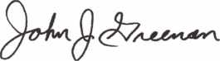

John J. Greenan, CML, CPS

Keynotes

November 1999

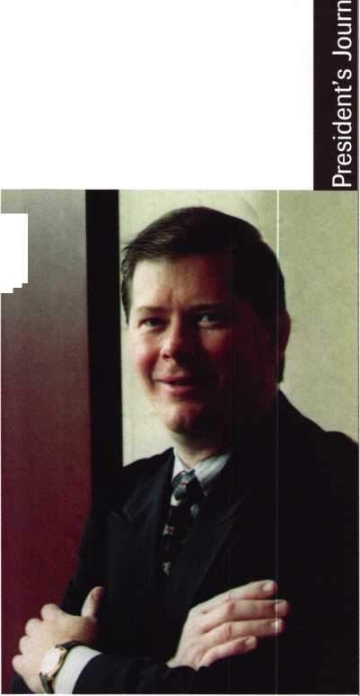

The Brightest And The Best

Kwok-kei Leung

Toshihiro Asa no

Henry Raymond

Stewart Levine, CML

.Charles Robertson, CML

Mary Ohmit, CPL

Yuriko Yanai

Jack Hobin, CPL

Allen Konrath

_Salvatore Dulcamaro, CML

Myeong-Rae Cho

William Neff, CML

David Lowell, CML

|  |  |  |  |
| --- | --- | --- | --- |
| 32 | Thomas Freehling, CML | 15 | Walter Lascar RJ |
| 31 | Dana Barnum, CML | 15 | i-ajtai, r\u  Thnmac V^nrlprct’ppn PMl |
| 31 | John Heckman, CML | 15 | Niumao vai luci 1, LrlL  William Grant fRI |
| 30 | Jeanne Lodge, CML | 15 | —— »» »tug11» vjiuiic, v,l\L  Garv Tpams fPI |
| 29 | Barry Leas, CRL | 15 | William McFIHenpv/ PMI |
| 26 | J Thomas Hood, CML | 15 | VVILUC4MI IMvLU ICI ICY/ LlVIL  Robert Duman GMI |
| 24 | Danny Rudd, CPL | 15 | Russell Fuller fRI |
| 24 | John Elliott, CML | 14 | Rex Parmelpp Rl |
| 24 | Larry Warnick, CML | 14 | James Gruber fRI |
| 24 | Roy Renderer, CML | 14 | Rrirklpr PRI |
| 24 | Jim Williams, CRL | 14 | yaiiitj Ul ILMCI, Ll\L  Mirhael Grn\/ec |
| 23 | James Watt, CML | 14 | Daniol 1 3nrlm |
| 23 | Robert Carroll, CPL | 13 | Ualllcl Landry  Edwin W ^cntt |
| 23 | Robert DeWppsp, fPI | 13 | — njvviii vv JLULL  Ppfpr (lpiithipr fPI |
| 22 | Diana Barnum, CRL | 13 | rcLci udUUMcl, LrL  Frank Hartnnn PMI |
| 21 | Anthony Ramunno, CML | 13 | — * i C4 * 11\ iiaiLLMiu, LIVIL  Jon Griswold fMI |
| 21 | Jerome Cohen, CML | 13 | Paul Snuher |
| 21 | David M A Federico | 13 | 1 oul JUUUCI  Richard ^ieverc |
| 21 | Eugene Altobella | 13 | i\iLi iaiu JICVCI j  Joe Lpp rR1 |
| 21 | William Lee | 13 | yuc Lee, v^ixL  ^■f-pv/pn ^rnui/ak CPI |
| 20 | Charles Cole, CML | 12 | jlcvci i jpiWal\f LixL  Robert Rodockpr PR| |
| 20 | Elvis Hammerschmidt, CPL | 12 | Keirvu Tsukishirn fRI |
| 19 | Marian Swann, CRL | 12 | y u i oLii\l jl 111 u, LlvL  Rolando Boii7a |
| 18 | John Shandy, CML | 12 | 1 nnmp MrKinnpw pmi |
| 18 | John Dorsey, CML | 12 | LUIIMIC ImLIx 11 11 1 rvl L  John Fnnel TRI |
| 18 | D Michael Lee, CPL | 12 | uuim Liiyci, Ll\L  Donald Shiles |
| 18 | James Fowler, CML | 12 | L/vl lULU Jl 1 IlCj  Fnr \/p^I |
| 18 | David Harris, CML | 11 | LI iL Vcdl  Hprhprt Diicpnhprrv/ PM 1 |
| 17 | John Kerr, RL | 11 | i ici uci l L/Uocl 1 JJcl 1 y, LIVIL  Ravmnnd 1 nek CMI |
| 17 | Keizo Takahashi, CRL | 11 | ixayniuiiu LUbK, LIVIL  Dale Knowlps GPI |
| 17 | Ronald Heidzig | 11 | Rohin Hnrslew |
| 17 | Philip Rovenolt, CPL | 10 | ixuuiii 1 IUI jLCy  Thomas Dpmnrrh CMI |
| 16 | Lawrence Smith, CML | 10 | * i ivjm luo l/CIIIUI IL^ LIVIL  Ernest Wrinht |
| 16 | Joseph Ferrero, CML | 10 | LI 1 ICJL vv i i u i i L  Wlllir^m WirkwarH FMI |
| 16 | James Cawby, CML | 10 | vviLuaiii wiLlswaiU, LlvlL  1 pcf-pr RrnHckw |
| 16 | Michael Robinson, CRL | 10 | LCj l“ i DfUUbKy  Josenh Whitaker fPI |
| 16 | Brian Reetz | 10 | ^j v- p 11 win Laixci, LrL  James Hawley, CRL |

How can I Join tR?Pfe$ldent's Club?

You can earn membership in this prestigious club by  
recruiting just 10 new members for ALOA.

*Any ALOA member may participate.

What do I get?

When you recruit 10 members, you receive a handsome  
blue blazer with a President's Club crest. For each  
additional five members you recruit, you receive a  
lapel pin with gold-filled numbers, indicating your  
recruiting successes.

You also get the satisfaction of knowing that you are  
helping your association, helping your industry grow,  
and you are helping fellow locksmiths achieve success.

How do I get started?

Contact the ALOA office for a supply of applications  
(800) 532-AL0A or FAX (214) 827-1810. One President's  
Club credit is awarded for each new applicant. Credit is  
awarded only after the membership application is  
approved. However, the credit will apply for the period  
in which the application is received. Failure to identify  
yourself as the sponsor on the application form at the  
time it is submitted to ALOA for processing will forfeit  
any credit.

*ALOA Board of Directors not eLigiblefor membership in the President's Club.



core

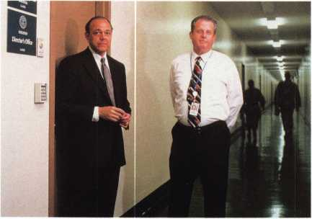

Group 4’s John Cases with Pentagon Physical Security Specialist, David Peake.

• Group 4 to service Pentagon

There are few doubts that one of the biggest access control  
jobs in the world would be servicing the Pentagon.

Undaunted, Group 4 Technology has Stepped up to the  
plate and has assumed the responsibility for the building’s  
protection. Utilizing its AMAG system, Group 4 will start with  
Wedge 1 of this historical structure, then proceed to service the  
remaining Four Wedges. All of this is line with the building’s  
refurbishment program, which is scheduled for completion in  
approximately 10 years.

The prime contractor for the design and renovation of the  
Pentagon’s security system is Integrated Systems Group at  
Radian Inc., who has enjoyed a healthy relationship with  
Group 4 as well as the Department of Defense.

The first test installation of the AMAG system was at the  
Navy Annex Building (not too far away from the Pentagon).  
After its success, it was then employed in the main corridor  
of the Pentagon, which holds some of the busiest traffic in  
the complex.

According to Bob Sawyer, CEO and President of Group 4  
Technology’s US operation, his company’s involvement with a  
high profile, high security facility such as the Pentagon solidifies  
the success of AMAG and its ultimate potential.

“It confirms we have a world class product capable of  
controlling and recording the movements of exceptionally large  
numbers of people in one of the most sensitive and security  
conscious buildings on the planet,” he says. “AMAG access  
control systems are already in place at military installations and  
government sites around the world, as well as in embassies,  
banks, production plants and office buildings.”



Keynotes

November 1999

• Radionics receives honors

The Security Industry Association selected Radionics’ C900 Dialer Capture Module (DCM) as one of the “Security Industry’s Finest.” This honor came at the ISC East Show in New York, where the C900 also received the “Product Achievement Award” in the Monitoring category. The device connects Radionics’ panels to TCP/IP data networks for remote signaling with frequent supervision and integrated phone line backup. It does this without removing installed systems and includes an integrated Network Interface Module to improve reliability and reduce installation and service costs.

For more information on the C900 Dialer, contact Radionics at (800) 538-5807 or at <http://www.radionicsinc.com>.

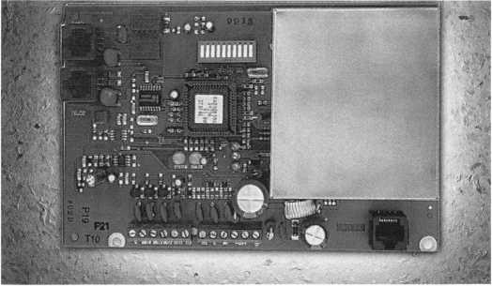

Radionics’ C900 Dialure Capture Module

• HES unveils Electric Strike Source CD

HES, Inc., specialists in electric strike technology recently introduced the Electric Strike Source CD. It boasts current multi-media and data management technology and has few hardware restrictions. It also uses a query based, graphic selector to guide the user directly to the electric strike and faceplate option best suited to the individual application. By touching a button, installation information, production specifications, common applications or additional directions are made available to better service customers. This product is aimed at wholesalers, distributors, architects and locksmiths. For more information, check out HES new web site at www/hesinnovations.com or [www.electricstrikes.com](http://www.electricstrikes.com).

PRP

When you yet fast,

|r\e;<pemWe laceinentloc^^nd keys^from

EBLA/D Automotive

Automotive Locks, Keys, Service Kits, Manuals & Training  
for the Professional Locksmith

**Fora list of BWD VATS Centers and a Seminar Schedule, see offer below.**

**FREE!**

**1999 Illustrated Automotive Parts Catalog**

including BWD Service Manual Library Centers,Distributors,  
VATS Centers, Seminar Schedule, and more... call

**(800) 647-4926**

**or take your web browser to [www.alllock.com](http://www.alllock.com).**

CRL

Skip Bladen, Chicago, IL Michael L. Childers, Dalton, GA Glenn Hove, Chester NJ Glenn Ross, Lubbock TX Stephen Secrest, Cincinnati, OH

• Regions

The Fox Valley Chapter of ALOA is holding its next meeting in conjunction with a tour of Strattec in Milwaukee,

WI. on December 14. For details, contact the Fox Valley Chapter at 1425 N. Richmond St., Appleton, WI. 54911 The Central and Southern Colorado Locksmith Association is conducting an Educational Seminar on December 4 at the Castle Rock Fire Station #1 at 300 Perry St., Castle Rock, Colo. 80104. For more details or to send your payment of $35.00 to CSCLA c/o Barry Meyer-Treasurer,

421 Perry St., Castle Rock, CO 80104.

The Grand Canyon Chapter of ALOA will hold its annual dinner meeting on December 4 at the Wyndham Garden Hotel, 427 N. 44 St. in Phoenix, AZ. For more information, contact Bob Arthur at (623) 846-7750 or (623) 848-0685.

WE’RE KEYED TO

YOUR NEEDS

Our brass key blanks are available in all  
popular numbers. Order 1000 - mixed or  
matched. Packed 50 to a box. $102 per  
1000 (Ford $14 per 100) F.O.B. Detroit.  
Prices subject to change.

INSTOCK:

Key Blanks Key Machines Locksmith Tools & Supplies Locks of All Types American & Foreign Automobile Locks Security Hardware (Wholesale Only)

_AM1-41C-1041C _AM3-J41-1046 AR1-135-1179 AR3-N1179A AR4-135A-1179A B1-98M-1098M B2-H98M-H1098M _B5-98DB-1098DB B10-H98LA-H1098LA B11-098LA-01098LA _B24-H98X-H1098X B44-X98E-P1098E _B45-098H-S1098H B46-X98J-P1098J ~B47-098K-S1098K _B48-P91A-P1098A B49-S91B-S1098B B50-P91C-P1098C B51-S91D-S1098D _B52/B4-98X-1098X BE2-A114A-A1114A BN1-L54P-K1122D _B01/HL2-22B-R1003M CG1-41G-1041G "CG2-41GA-1041GA CG4/CG3-41GR-1041GR _CG16-41R-1041T JGG17/KP1-41Y-1041Y CG22-41RB-1041E C01-20-1000 C03-21EB-1001EB C07-21EN-1OO1EN C010-20G-1000G JC026-20V-1000V C068-20VS-S1000V _C087-22Z2-1001EH C088/C066-A22Z2-A1001EH _C089-A22GM-A1001ABM C091-A22A1-A1001AH C097-K22-1001GH ~C01 06/HL 1-R22B-1003M DE6-54DR-D1054K EA1-61-1014 EA2T€A50-X61F-X1014F EL10-C1096CN ER1-119-1119

ES8-1502 FA1-F54-1054WC 'FR2-L54G-L1054G _H26-127ES-1127ES H27-127DP-1127DP _H50S27-S1167FD _H51-P27-1167FD H54-PS23F3-1184FD _H60-1190LN _H03-170-1170B _HR1-X61FR-1014C IN1-54F-1054F IN3\ IN20-X54K-1054K IN8-L54B-L1054B IN18-X54F-X1054F JN28-54FN-1054FN IN29-1054UN IN33-54MT-1054MT IN35-1054DL K2-79HK-1079B KW1-54KS-1176 LI-35-1004 _L4-35A-1004A MI-92-1092 "M2-92B-1092B _M4-U92A-1092V M10-92N-1092N "M11-92T-1092H ~M2 7/M 16-92NR-1092NR _NA12-174BN-1069LA NA24-1069LC "NA25/NA6-N174D-R1064E NH1-N102-1177N _RA3-99B-S1970AM _RA4-99A-1970AM R01-62-1069 R03-174J-1069N RU1-5&1011 _RU4-55P 1011P _RU16-57PA-A1011P "RU45-57-1D-1011D1 RU46-A57-1D-A1011D1 _S1-48-1009

_S3-50-1010 _S4-050-1010U _S6-049KM-N1007KMA _S16-49KM-N1007KMB _S22-043LA-01007LA ~_S221/2-43LA-1007LA S32-48KMR-N1007RMB S68-51S-1010N _S69-51SA-L1010N SC1-145-1145 _SC4-145A-1145A SC6-307A-1307A SC7-145FS-1145F SC8-145ES-1145E _SC9-145E-A1145E SC10-145F-A1145F ~SC20-145L-A1145L SC22-307W-1307W ~SE1-102-1022 _SE8-102AB-1022AB SK1-R21EN-R1001EN T3-111E-1141E J7-111GE-1141GE WEI-133-1123 M2-175W-1175N WR3-54WB-1054WB ~WR4-54WA-A 1054WB WR5-54WC-N1054WB WR6/FA2-F54A-A1054WC XL7-XL16-1180S Y1-14-999 Y1E-E14-999N Y2-14A-999A Y3-14YM-C999 Y4-12GM-998 Y6-7X-997X Y11-7NX-01122 "Y12-07NX-01122A Y13-R7NX-01122R Y14-R07NX-01122AR Y52-7E-997E Y54-07E-0997E Y103-07B-01122B Y149-S19-S1770U _Y152-PI 9A-P1770U _Y220-X14S-999B

STOCKING DISTRIBUTORS FOR:

A-1 Security Mfg.

Abus Lock Co.

Alarm Lock All Lock Co.

American Lock Co.

Arrow Lock

Auto Security Products

B.E. Industries, Inc.

CCL Security Products Detex

Don-Jo Mfg. Co.

EMTEK

ESP Lock Corp.

Fort Lock Corp.

Framon Mfg. Co., Inc.

Harloc HPC, Inc.

Hudson Lock Co.

ILCO Unican Corp.

Keedex

Keystone Novelty Co.

Key Systems KSP

Kwikset Hardware Group LAB

Lori Corp.

Lucky Line Products Corp.

Mag. Engs. & Mfg. Co., Inc. Master Lock Morse Tools Multi Lock, Inc.

S. Parker Hardware Pro-Lok Co.

Quincy Mfg. Co.

Schlage Lock Co.

Silca

STRATTEC

Supra

Trans-Atlantic Co.

Trine Mfg. Co.

Wilson Bohannan Co.



Send in order or

request order  
form.



1-800-445-KEYS (5397)  
313-931-7720

Fax: 1-800-828-KEYS (5397)

Local Fax: 313-931-7758  
9950 Freeland  
Detroit, Michigan 48227

November 1999

Keynotes

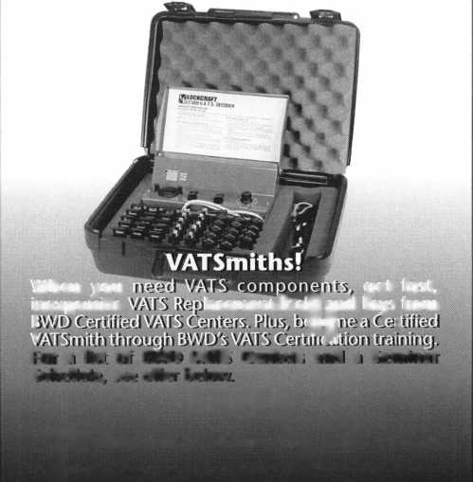

Upcoming

Events



Dept)

NOVEMBER

3

Simplex Unican Certification Class Fort Wayne, IN

Northern Indiana Chapter of ALOA Contact: Karen Fisher (219)223-8367

1. 7

★ Fall ALOA Board Meeting Sturbridge, MA (800) 532-2562

1. 10

Yankee Security Convention Ace Classes **fk** PRP Sitting Sturbridge, MA Yankee Security Contact: Rob Mahoney (800) 209-8266

5

**^** ALOA PRP Sitting Dayton, OH Ohio Valley Chapter Contact: Bill Lockwood (937) 836-6127 (937) 775-3736

2000

FEBRUARY

9-13

TLA Annual Convention and Trade Show **fk** PRP Sitting Houston, TX

The Texas Locksmiths Association Contact:

Registration info: Jim Hetciller (830)606-1727

Exhibitor info: Robert Hernandez

(210)433-5397

General info: (877) TLA-INFO

JULY

24-30

ALOA 2000 Security Expo Las Vegas, NV (214) 827-1701

2001

MARCH

28-April 1

MLANJ 2001 Annual Convention Somerset, NJ (973) 267-8884 (973) 538-2248 fax [www.mlanj](http://www.mlanj) .org

JULY

16-22

ALOA 2001 Security Expo Baltimore, MD (800) 532-2562

13

**fk** ALOA PRP Sitting Dallas, TX ALOA

Contact: David Lowell, CML, CPS (800) 532-2562 (214) 827-1810 fax

16-20

The California Locksmiths Association 1999 Educational Trade Show Convention Los Angeles, CA

Quality Hotel @ LA International Airport Contact: Mark Anderson

(415)479-8879 (714) 632-6800

20

Oklahoma Master Locksmiths Association ACE Classes Oklahoma City, OK Contact: Lowell Roberts (405) 732-5838 (405) 741-5838 fax

DECEMBER

5

**jk** ALOA PRP Sitting Dallas, TX ALOA

Contact: David Lowell, CML, CPS (800) 532-2562 (214) 827-1810 fax

MARCH

17-19

Trade Show & Security Conference Troy, MI

IDN Hardware Sales, Inc

Contact: Fred Strasberger or Bonnie Weston

(800) 521-0955

2002

JULY

22-28

ALOA 2002 Security Expo Rosemont, IL (800) 532-2562

APRIL

6-9

MLANJ Annual Convention Ace Classes

Master Locksmith Association of New Jersey

Somerset, NJ

(973) 267-8884

(973) 538-2248 fax

[www.mlanj.org](http://www.mlanj.org)

19-23

Easter Convention Birmingham, England Master Locksmiths Assoc in the UK Contact: Mick Friend [Mick@locksmiths.co.uk](mailto:Mick@locksmiths.co.uk)

MAY

1-6

SAFETECH 2000 Birmingham, AL (214) 827-7233

**VV** Indicates ALOA ACE Class

Indicates PRP Sitting

***Keynotes***

November 1999



Need information in a hurry?

Just call 310.575.5074 and you will be faxed:

ALOA  
HAS  
FAX ON  
DEMAND!

Your association continues to explore  
ways to provide you, our members,  
with new benefits and services.

#1

#2

#3

#4

#5

#6

#7

#8

#9

#10

#11

#12

#13

#14

#15

#16

#17

#18

A list of all documents available through this service

Becoming A Locksmith  
Locksmith Career Summary  
Locksmith School List  
ACE Class Schedule  
Certification Information  
PRP Category List  
ALOA Membership Application  
ALOA List of Benefits  
Scholarship Application Form  
ALOA Video Library Order Form  
ALOA Membership Items Order Form  
Safe & Vault Technicians Association  
Member Application/Subscription Form  
ALOA Chapter Roster  
Legislative Action Network  
Legislative Action Network Newsletters  
Various State Laws  
Industry Position Paper

November 1999

Keynotes

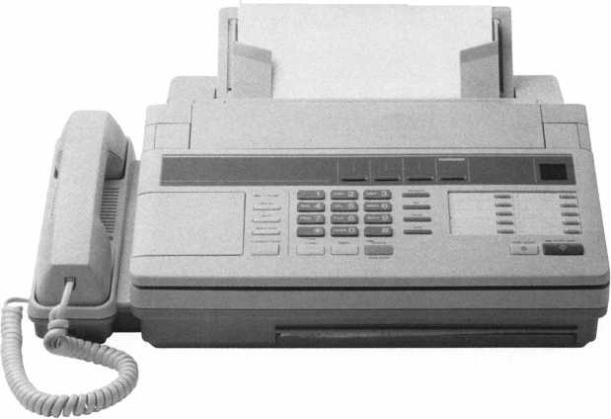

Security

Marketplace

Kroy

Kroy LLC has introduced a label supply for Brother P-Touch labeling systems that use TZ tape. Its new K-Tape provides Brother TX tape users with an alternative tape supply for their P-Touch label printers. Kroy’s K-Tape is available in half-inch and one-inch sizes. Both tape supplies work in Brother models PT-330, PT-350, PT- 520, PT-530, PT-540, PT-550, PT-580, PT-2500-PC, PT-9200-PC, and PT 9400. The half-inch supply also works in Brother PT310 and PT-320.

Kroy

3820 Kelley Avenue Cleveland, OH 44114 (888) 888-5769 [info@kroy.com](mailto:info@kroy.com)

Security Source

Now on the internet is SecuritySource.net, a one-stop directory and supplier catalog for the security industry designed to eventually show a full complement of access control, burglary, fire and home automation equipment, ancillary service, industry news and information.

Security Source 4 Wood Hollow Rd.

Parsippany, NJ 07054 (973) 503-1919 (973) 503-1803 fax unvw.SecuritySource. net info@ Security Source, net

Videx

Now available from Videx is ToucliAccess, a lock that provides an audit trail. It can be installed on file cabinets, storage containers, toolboxes and anywhere that controlled entry is desired. A record of every entry, closure, and denied entry is stored in TouchAccess and can be immediately transferred to a Palm organizer upon request. Authorized users can be issued a Touch Memory key that contains a unique ID number. Each time the authorized user opens and closes the TouchAccess lock, the user ID number is recorded along with the date and time of the event. Since it incorporates a mechanical lock, it does not permit unauthorized entry. If forced entry is attempted, a local alarm will sound, alerting everyone in the surrounding area.

Videx

1105 NE Circle Blvd.

Corvallis, OR 97330 (541) 758-0521 (541) 752-5285 unvw.videx.com

Security Sales

Security Sales magazine offers the Y2K Preparedness kit, designed by an alarm dealer for alarm dealers to assist companies in the transition for the turn of the century. The kit is organized chronologically with a checklist of duties month-by month, beginning with the necessary Y2K tasks in August.

Security Sales South Western Avenue Torrance, CA 90501 (310) 533-2400 (310) 533-2500fax



Sieveking Products Co.

Sieveking Products Co. announces that is has added the Key Scope to its line of tools. This new wafer lock reading tool incorporates features not found in any other scope. Key-Scope has a variable intensity High Output light. The longer wafer depressor allows the locksmith to read wafers in deeper keyways. There are two viewing lenses on Key-Scope. One lens is short focus for standard keyways, the other is long focus for deeper keyways and safe work. Used together, the Key Scope lenses ADD, the give a higher magnification, for reading those hard to see impression marks. A padded “Hard-Shell” case in included for protection.

Sieveking

3437 South Bend Rd.

Rockford, II61109 (815) 874-4030 (815) 874-5713 fax

llco Unican

The Unican Lock Division of llco Unican proudly introduces the 64 Series lime Lock. The case is constructed of all metal with a fiill-face cover of clear acrylic. The 64 Series Time Lock is available with standard movements, reset movements, reset with accelerated action movements or the electronic movements featuring audit trail. Traditional mounting hole pattern and case dimensions with optional inserts for 1/4" -20 mounting bolts make for easy fitting or retrofitting. **llco Unican Corp.**

29412 Indiana Ave.

Winston-Salem, NC 27105 (336) 725-1331 (336) 725-3269 fax ivtvw. ilcounican.com

Javelin Systems

Javelin Systems introduced its Easy Reference Guide with information on the company’s CCTV equipment-multiplexers, quads and observation systems, as well as patented covert cameras (100 Series). The guide also contains seven brand new items including camera mounts, video switchers and 21" color video monitors. The Easy Reference Guide showcases products and prices. **Javelin Systems (800) 421-2716 unvw.javelin.com**

Stroamlight, Inc.

Streamlight has introduced a new series of alkaline battery- powered flashlights that provide extreme durability at a more affordable price. Streamlight s ProPolymer series features three flashlights - the Streamlight 3C, 2AA and 4AA. Each light in the ProPolymer series is designed in a Polymer case. The soft rubber non-slip grips are co-molded into the case and can be used in environments where the flashlight can be slippery or hard to grasp. Each roll-resistant flashlight has a rubber face cap for impact and shock resistance as well as an unbreakable polycarbonate lens. All three are submersible in water up to 200 feet.

Streamlight

1030 West Germantown Pike Norristown, PA 19403-3996

***Keynotes***

November 1999

Marks USA

Electrified Survivor Series locksets with the “Clutch” are available for operation as either electrically locked or unlocked. When locked, the Survivor s clutch disengages the outside lever allowing it to turn freely without opening the latch. Marks USA locksets feature lifetime mechanical warranty. Survivor locksets are UL listed for three hour fire rating and satisfy all ADA requirements.

Marks USA

5300 New Horizons Blvd.

Amity, NY 11701 (516) 225-5600 (516) 225-6136fax

LCN Division-lngersoll Rand Company

A new closer is being introduced by LCN for aluminum store front doors. The 1371 Series Quest door closer has a design geared toward aluminum storefront doors. It can be used with hinge or pivot-mounted doors and cane be mounted on a 1-1/2” transom without adapter plates. Its unique design clean, simple lines and mounting screw are completely concealed when closer endcaps are applied. The closer carries a 10-year warranty and features a cast iron cylinder with a bore diameter of 1.25 inches. It includes gear teeth and all temperature fluid is standard.

LCN Closers PO Box 100

Princeton, IL 61356-0100 (800) 526-2400 (800) 258-1460fax [www.lcnclosers.com](http://www.lcnclosers.com)

Schlage Commercial Lock Division

Ingersoll Rand s Architectural Hardware’s Schlage Commercial Lock Division introduced RapidKey™ programming which provides features that include 95/98 compatibility, help screens and configuration menus and the ability to manage a wide range of time and user access functions. Designed for use with Schlage s e.Primus system. Its application can be used in schools, hospitals, offices stores and other facilities needing more sophisticated key control. Enhancements include compatibility with Windows 95 and 98, allowing user integration with existing systems. An automatic adjustment for Daylight Savings Time has been added can be disabled for use in areas where it does not apply. User assistance is provided through online help, as well as a Quick Reference Manual. Audit trails can now be established either by door or by user. Once the information has been collected in the RapidTour program, information can be viewed on all entries by a specific individual as well as all individuals accessing a particular opening.

Schlage Commercial Lock Division 1915 Jamboree, Ste. 165 Colorado, Springs, CO 80920 (719) 264-5300

Audio Visual Supply

Audio Visual Supply, a manufacturer and supplier of industrial CCD cameras, recently launched the CVA-32X low light color camera to provide solutions for low light image capturing situations. It employees technology to allow for color picture to provide solutions for low light image capturing situations. The CVA-32X employs new technology allowing clear color pictures obtained at an extremely low light requirement of .005 lux. Key to the technology is a custom designed digital processor chip and filter that signifi­cantly reduces noise levels for low light conditions. Long time exposure and dark current noise features also enhance the cameras image capacity.

Audio Yideo Supply (800) 284-2288 (858) 565-7845 fax [prodinfo@avsupply.com](mailto:prodinfo@avsupply.com) ivww.avsupply.com

Lockmasters

Lockmasters is offering change keys for combination locks, that until now, were obsolete. These change keys are machined from steel. The change keys fit into an anodized aluminum handle and can be interchanged. Change keys offered include Mosler 302-402, 1132 Time Delay, 1839 Vault Lock and 120 Series, LaGard Vault Lock, Diebold 177 Series, 180 Series and Sargent and Greenleaf 6720 and 6721 Series.

Lockmasters 5085 Danville Rd.

Nicholasville, KY 40356-9531 (800) 654-0637 (606) 885-7093

WinWhatWhere Corporation

WinWhatWhere Corporation released Investigator 2.0, computer activity monitoring software. Investigator 2.0 invisibly monitors all keyboard and application activity to provide comprehensive and detailed forensic information on computer usage. The program features automated stealth email notification, performance and an optional Silent Install utility for discrete deployment. Investigator 2.0 is tailored for “behind the firewall” investigative and security needs of network administrators for discovering computer fraud and misuse in exact detail. Investigators ability to invisibly monitor all keyboard and application activity make it suited to the needs of business, law enforcement, government and private individuals. **WinWhatWhere Corporation 925 W. Kennewick Ave.**

Kennewick, WA 99336 (509) 585-9293 (509) 585-9294fax [www.winwhatwhere.com](http://www.winwhatwhere.com)

November 1999

Keynotes

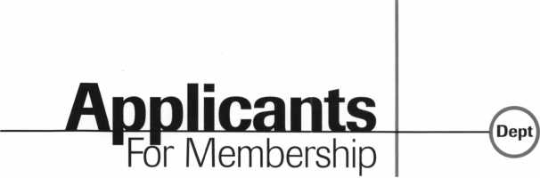

***The following applicants are scheduled for clearance as members of ALOA. The names are published for member review and comment prior to November*** *1****,****1999****, respectively, to ensure applicants meet standards of ALOA’s Code of Ethics. Protests, if any, should be addressed to the Membership Department and must be signed. Active Membership applicants (AJ have worked in the industry two or more years. Allied Membership (ALJ applicants are not locksmiths, but work in a security-related field. Apprentice Membership (AP) applicants have worked in the industry less than two years. A***

Clearing December 1:

USA

ARIZONA

Phoenix

Chris M McAllister, AP

COLORADO

Colorado Springs

Paul D Ray, AP

FLORIDA

St. Petersburg

Matthew L Hancock, A

GEORGIA

Buford

Christopher A Fitzpatrick, A

East Point

Wilburn K Yarbrough, AP

ILLINOIS

Chicago

Kenneth A Melton, A SPONSOR: Dejan Nikolich

Lockport

William M Hartgrove, A SPONSOR: Mark Blum

Vernon Hills

Karl Waller, A SPONSOR: Kevin Ahrens

INDIANA

Indianapolis

Gary L Moran, A SPONSOR: Jim Williams

Newburgh

029222, Lucien L Hayden, A

MARYLAND

Clarksville

Nelson M Durham, A SPONSOR: Richard Cohen

MAINE

Portland

Wayne S Kimball, A SPONSOR: John Havens

MISSOURI

N. Kansas City

Timothy J Helfrich, AP SPONSOR: Dale Knowles

NORTH CAROLINA

Red Springs

Betty J Micheals, A

NEW JERSEY Denville

Steven DeSalvo, A SPONSOR: Barry Leas

Elmwood Park

Daniel C Counterman, A SPONSOR: Thomas Ware

NEW YORK

Bellmore

Edward J Goller, A SPONSOR: Robert Duman

New Rochelle

Kenneth E Bond, A SPONSOR: Paul Cordaro

OHIO

Indepenence

Loren S Young, A

PENNSYLVANIA

Harrisburg

John Mateer, A SPONSOR: Rod Snell

TEXAS

Carrollton

Gary A Hardima, AP SPONSOR: John Arnold

Dallas

Alan B O'Daniel, A

LaGrange

Craig T Bednar, A SPONSOR: M Terry

Orange

Edward J Michael, AP

VIRGINIA

Herdon

Lauren E Killip, AP

WISCONSIN

Madison

David M Hornung, A SPONSOR: William Lee

BELGIUM

Erembodegem

Eric LeBlanc, A

CANADA

ONTARIO

Carleton Place

Steven J More, A

HONG KONG

North Point

029248, Yiu-Fai Tam, A

ISRAEL

Tel-Aviv

Jacob Friedman, A

JAPAN

KANAGAWA

Tama-Ku, Kawasaki

Etsuo Sato, A

SPONSOR: Toshihiro Asano

Zama

Mitsuo Kashiwagi, A SPONSOR: Toshihiro Asano

OSAKA

Osaka City

Noriko Minamiura, A SPONSOR: YurikoYanai

TOKYO

Adachi-Ku

Kunihide Kanbe, A SPONSOR: Toshihiro Asano

Shibuya

Kusuwaki Hirohito, A SPONSOR: Toshihiro Asano Morita Katsutoshi, A SPONSOR: Toshihiro Asano

Shinagawa-Ku

Norihisa Ara, A SPONSOR: Toshihiro Asano

Shinjyuku-Ku

Awaji Yasuo, A SPONSOR: Toshihiro Asano

TAIWAN

Taipei

Chiang Chien, A SPONSOR: Katsuyoshi Hayashi

Keynotes

November 1999

“If you want to study for the CPS test,

you need this book.

Without that book, I wouldn’t have my certification.”

-Dennis Johnson, CPS  
Aurora, Illinois

Mike's new book is very  
consistent with the study  
information required to pass the  
SAVTA/ALOA CPS certification  
test I wouldn't have passed  
without it. A tremendous  
resource for today  
and tomorrow..."

-John T. Grist, CML, CPS  
North Georgia Security

"The Safe Technicians Reference Manual by Mike Oehlert ranks among the best technical reference and learning aids you will find in the safe and vault industry. It contains page after page of essential information and easily understood illustrations. Besides answering most of the questions commonly asked by technicians new to the field, Mike has also included plenty of information experienced technicians will find useful."

-Ken Dunckel Pacifica, California

—►Over **600** Illustrations.^—

320 **pages.** Only $135.

What are you waiting for?

To order, call 800-532-2562. Allow 3 weeks for delivery.

All major credit cards accepted; or make check payable to ALOA.

The Safe

Technicians  
Reference Manual

First Edition

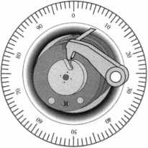

**By Claire L.**

What characteristics do successful locksmith/business entrepreneurs possess? They have tremendous belief in their abilities, technical knowledge, and in their vision for doing things that allow them to earn a profit. They are prone to action and don’t worry about making a few mistakes. They learn from their mistakes. They understand that when the business succeeds, they’ll succeed, so they focus their energy on building a successful business.

Imagine the possibilities, if every employee of the ABC Locksmith Company shared these same beliefs in their abilities and in the purpose of the business. If they believed that there were rewards for exercising initiative and in demonstrating value to your customers and profit for the business.

If every employee in an organization shared the following beliefs, your business will have created an ownership culture. Everyone in the company would think and act like entrepreneurs or like owners of your business. That’s the power of an ownership culture.

* Believe in the leader
* Believe in the purpose of the company
* Believe in the policies and procedures
* Believe in empowerment
* Believe in reward

Believe in the Leader

When everyone in a company believes in the leader, a high level of trust develops. Belief in the leader means that the people in the company believe that the leaders have the business acumen and talent to succeed.

**Keynotes** November 1999

Believe in the Purpose of the Company

Most people want to be a part of something big. They want to share in the creation of something important. They want to believe in the purpose of their company. Your employees want more than job. They want to be part of changing the world, even if it’s just their own littler corner or it.

Believe in Policies and Procedures of the Company

The employees in your organization constantly pass judgment of your currently operating company. They evaluate whether it makes sense, given their view of the world. They compare your operating company to those of other companies where they have worked, to those of your competitors, and to the companies described in the trade publications they read.

As a leader, your job is to help employees find reasons to believe that your company policies and procedures make sense. To explain your thinking and answer their questions as to why certain policies exist so that they understand the larger picture.

Believe in Empowerment

The real benefit of working in an ownership culture is the ability to act on your own with the full support and backing of the organization. Therefore, your have authorized members of your organization to make decisions on behalf of the company.

But even more important, you train them to make the right decisions on behalf of the business. Just authorizing people to make decisions is not enough. They won’t act unless they feel confident that they can act appropriately. People believe in

empowerment when they have the authority and the ability to act, and receive support when they do act. Make sure everyone in your company believes in empowerment.

Believe in the Reward

When employees believe in the reward, they believe that they will succeed when the business succeeds. They are willing to give their best efforts on behalf of the business because they know that their personal success is tied to the success of the business. This is constantly on their minds. When you help every employee of your company stay focused on the big picture, they, in turn, try to improve the business so that their reward increases. They protect the bottom line as if it’s their won because it is their own.

When the above-mentioned beliefs are instilled in your company operation, your business becomes a finely tuned system and your employees become a real team. They believe in the game plan and focus on winning. Your business begins to operate on its own, without your constant attention.

You have more time to work on the business instead of working at the business. You have more time to improve its overall operation, to find new opportunities, to research new equipment, techniques, opportunities, to develop more people, and to stay focused on the changing market.

Ensure that everyone in your organization believes in the leadership of your company. Ensure that they believe in the purpose of your business. Ensure that they believe in the overall operation and that they believe in empowerment and the reward. Then let them do their thing. Get out of their way. Discover how powerful a company of entrepreneurs can be.



**BY SAL DULCAMARO, CML**

As locksmiths, we tend to collect and use a fairly good size assortment of servicing tools. Some are more useful than others.

There are some lock servicing situations where a variety of different tools will suffice to get the job done. Some methods will be a bit more convenient than others, but all are somewhat adequate for the task at hand. There are other situations where there are no practical substitutes for the “right” tool. Sure, you can manage to complete the job, but it takes a lot longer than it should. In lock servicing, there are some locks that become extremely awkward to work on when you don’t have the correct tool.

Most locksmiths have probably serviced the Kwikset 400 series residential knob locks. Removing the cylinder is a fairly straightfor­ward and simple task, providing that you have the correct tool. A flat blade tool, called the Kwikset cylinder removing tool, is needed to remove the lock cylinder for changing the hand of the lock or for rekeying/decoding. The tool is not overly complex. In fact, it is very simple in design and quite inexpensive. You can get a couple of the tools for less than $5.

If you have ever tried to remove the cylinder with a couple of flat blade screwdrivers (because you didn’t have the correct tool handy), you would know that a step that usually takes a few seconds can end

up taking minutes of frustration. A couple of locksmith tool companies make their own tool to remove the cylinder, but they cost between $20 and $40. The general shape and configuration of the cylinder removing tool is critical to the ease of removing the lock cylinder. The specialty tools that cost much more are generally easier to use than the basic Kwikset tool, but for me the difference in time to remove a cylinder is about three seconds to use the more expensive tools and about five to ten seconds for the inexpensive Kwikset tool.

Fairly recently, I found myself in a similar circumstance with another type of lock. For the lack of the proper (simple and inexpen­sive) tool, I ended up taking much more time than I should have.

Photo 1 shows a lock known as the WeiserBolt. The WeiserBolt is a key-in-knob lock with a dual function latch bolt. When unlocked, it acts as a spring latch, but when locked (and extended) it acts as a deadbolt. The concept behind the lock is that you can have a knob and deadbolt lock in one without drilling a second mounting hole for a separate deadbolt lock.

Looking at the shape of the protruding part of the latch, you might mistakenly think it is already acting as a deadbolt. This is the most recent incarnation of the lock, and it is indeed a spring latch in the illustrated condition. It has been designed in such a way that the

November 1999 **Keynotes** I,

latch doesn’t have to be changed or adjusted whether the door opens inward or outward. Because it is so bluntly tapered, though, the lip of the strike plate is much more severely tapered to allow the latch to compress as the door is closed. Earlier versions of the WeiserBolt had a latch bolt which looked much more like a standard shaped spring latch. The latch bolt fully extends into a one inch throw deadbolt by key operation from the outside knob or use of the turn button on the inside knob, as shown in photo 2.

SERVICING THE WEISERftOLT

To service or rekey the WeiserBolt, you will need to gain access to the lock cylinder. Photo 3 shows the back of the outside knob. I am touching the retainer ring with the tip of a small slotted screwdriver. This part must first be removed. With the retainer ring shifted up the fairly long lock cylinder tail piece, part of the mechanism can be lifted upward (photo 4). After the parts are removed, you can see part of the cylinder cap inside the round opening, in photo 5.

The tool designed to unscrew the cylinder cap is shown in photo 6. The side of the tool needed for this lock is at the left with the wider end that looks somewhat like a crown. It is shaped to mate with the 10 teeth of the cylinder cap. The other end works with the original version WeiserBolt that had a cylinder cap with fourteen teeth. I will explain how the other side of the tool is used, later.

The long tail piece fits inside the hollow center of the tool, as shown in photo 7. The tool is pushed inward until it engages the teeth at the back end of the cylinder cap. When the cap is engaged, the tool is rotated counterclockwise until the cylinder cap is free from the threaded back side of the cylinder plug. The lock cylinder is about to come out through the face end of the knob in photo 8.

The lock cylinder has been removed in photo 9. You can see the teeth of the cylinder cap which remains inside the knob. The cylinder, in photo 10, is now ready to be serviced. A standard plug follower can be used as you remove the plug for either decoding or rekeying.

THE ORIGINAL WEISERBOLT

The original version of the WeiserBolt was serviced in a slightly different way. The first few steps in disassembly of the lock are virtually identical. Photo 11 puts us at the point where the servicing procedure varies. For the newer version lock, I would have placed the hollow opening of the tool (used for unscrewing the cylinder cap) over the long tail piece, sliding it in until it engaged the cap. For the original version, the step is nearly the same, except that the opposite end of the tool is inserted to engage the cylinder cap.

The pattern on that end of the tool matches the fourteen teeth of the cylinder cap.

When the cylinder cap is fully unscrewed from the back of the lock cylinder plug, it can come out as in photo 12. This procedure is quite similar to servicing some versions of Weiser key-in-knob locks made prior to the existence of the WeiserBolt. So is the next step, shown in photo 13, where the cylinder plug is followed out of the entire outer knob assembly.

Photo 14 shows how the two different ends of the tool look side by side. The notches in the end of the tool fit within the teeth of the different style cylinder caps in order to depress the spring loaded retainer pin while rotating the cap for either tightening or loosening. It is called the 3-Way Cylinder Cap Tool. It has Weiser part number 1029, and it costs less than $4. It actually replaced two separate tools made by Weiser. A tool with the pattern shown at the left (for 14 teeth caps) had the part number 1416, and was used for the original WeiserBolts that were introduced somewhere in the mid 1980s. A more recent tool with the pattern at the right (for 10 teeth caps) had the part number 17604, and it was used on the redesigned Weiser-

Keynotes

November 1999

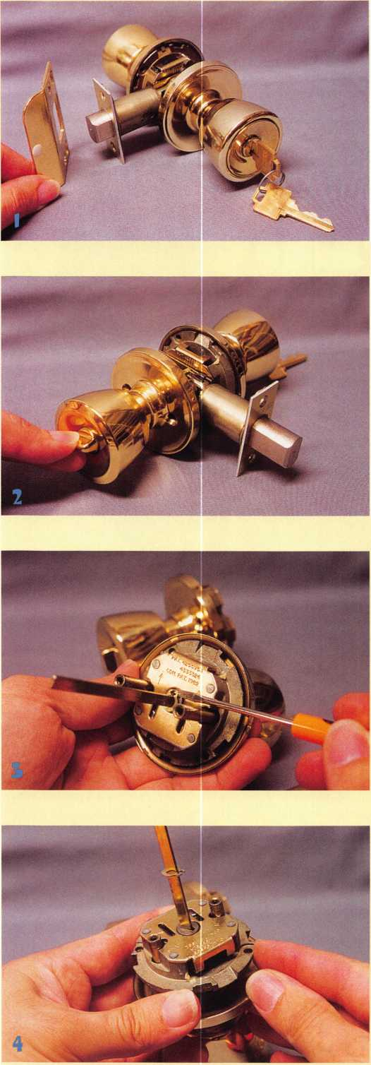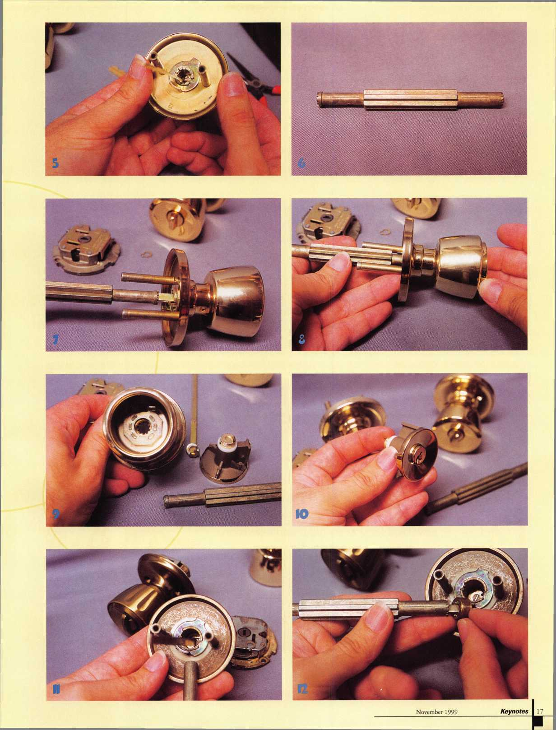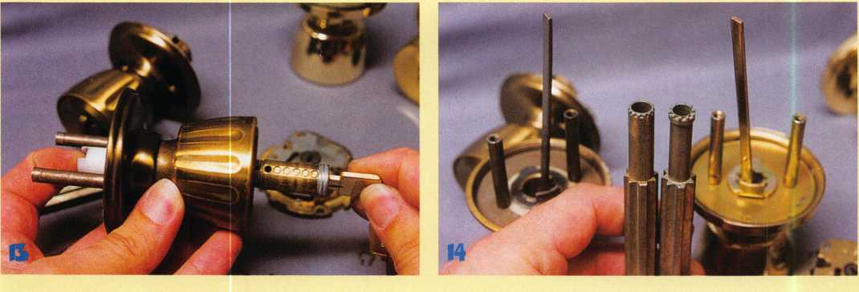

Bolts from the year 1991 forward. The 1029 tool replaces both the #1416 and #17604 tools.

A few months ago, I had the misfortune of having to rekey three of the newer style WeiserBolts without having access to any of the various tools designed to remove the cylinder caps. I spent more than an hour trying to make up a home made substitute for the right tool. Eventually I resorted to using a poke tool to reach inside the opening, as in photo 15, to depress the retainer pin and rotate the cap a few notches at a time. It was a cumbersome and tedious process without the proper tool, but I managed to take them all apart and reassemble them. If I only had the sense to buy the inexpensive tool beforehand,

I would have avoided an unnecessary headache. It pays to have the right tool for the right job.

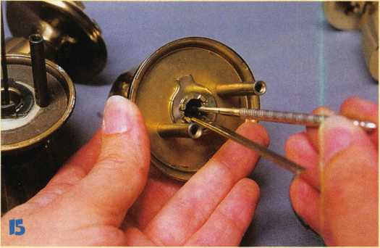

**BE A PART OF 1-800-LOCKSMITH!  
USE THIS NUMBER IN YOUR CITY  
& OWN THE MARKET!**

We are looking for qualified locksmiths who want to expand their business

and develop themselves into one of the largest locksmith operations

in their city. You will be authorized to use our logo and name

and we will advertise for you on radio and television.

Interested locksmiths will be able to "secure"

as large or as small a territory as they

desire. Territories will be based

on zip codes.

**Call today for more information or to sign up!**

Keynotes

November 1999



**BY DON DENNIS, CPL**

It was during this summer’s ALOA show in Cincinnati that  
I had my first look at the new Lock Tec Tools, a subsidiary of  
Mas-Hamilton, SoftDrill™ tool system. At first, it appeared as  
if it were simply another auto dialer tool with a big price tag.

I actually went by the booth where it was located several times  
before a display of opening times on a laptop computer screen  
caught my attention. Twenty minutes and 18 minutes were

normal readings. There was one that read  
33 minutes. Even at my best, I could not  
open, by manipulation, a lock without  
knowing a portion of the combination  
in that short of time. I figured that  
they must have been inputting a portion  
of the combination so I walked on.

There was another one of these machines  
working the other side of the convention  
floor. I figured the more the merrier  
and I kept searching for a good story to  
write about.

I was passing the Mas-Hamilton  
booth for probably the tenth time that  
morning when I heard the fellow  
displaying the tool say to his audience  
now it’s not an auto dialer. I kept on

walking until the end of the row of display booths when it finally  
began to hit home. “Not an auto dialer” kept bouncing around in  
my brain. I could not make it go away and yet it made little  
sense. I was accepting a give-away item from one of the exhibit  
booths when the whole thing came upon me like a load of bricks.  
Not an auto dialer? What did this thing have, a brain? My feet  
were moving in the direction of the display faster than the true  
realization of my questions.

I arrived at the booth, smiled and shook the hands of Kelly Kincaid and Howard Dame. I would not have remembered their names were it not for their business cards. I just stood there with a silly smile feeling like a sincere but dim-witted moron. I could not make a sentence or a question or anything. I just stood there completely overwhelmed by the implications of what I was seeing. Here was a tool that a locksmith could purchase that would open a mechanical safe lock in less than an hour. From what I had seen, it would perform its magic generally in less than 30 minutes. In fact, it would make a mechanical combina­tion lock system obsolete! It might even make the industry and the government obtain higher standards. Or should I say, force the industry towards higher standards. I was lucky that day, for

**November 1999 Keynotes**

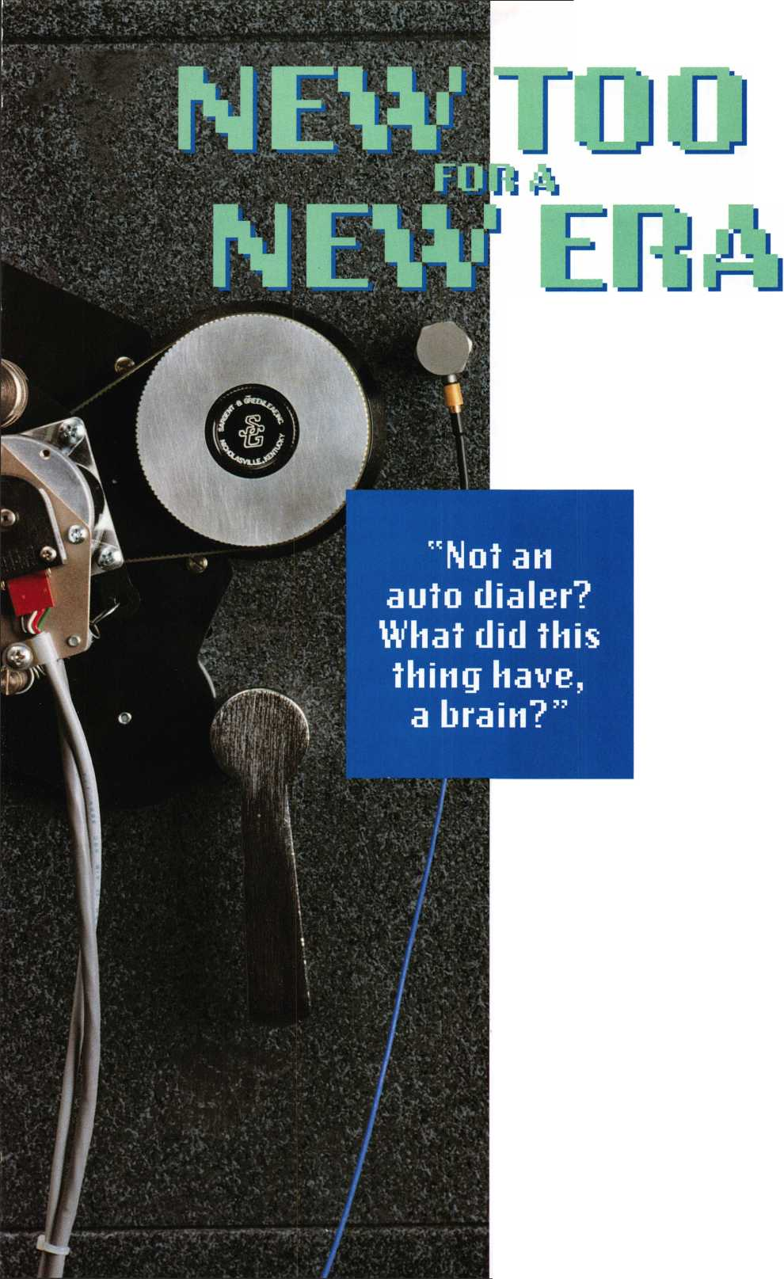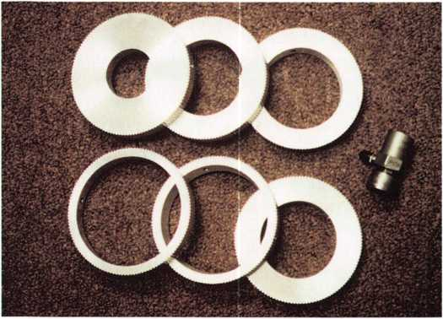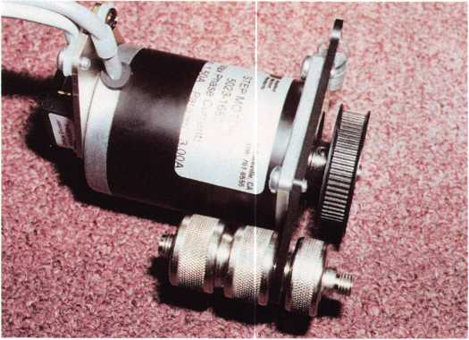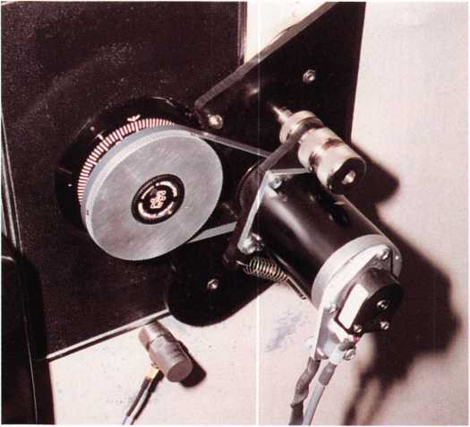

with limited speech, I was able to leave with a promise of visiting the Mas-Hamilton complex and seeing more of this invention.

One week later, I was in a room at Mas-Hamilton viewing the SoftDrill. I felt it a great privilege to get the invitation and not wanting to upset anyone, I chose to listen at what was being said and reserve my questions. What I did learn was more than I expected. First, a new company is handling the SoftDrill tool. Lock Tec Tools, Inc. is a subsidiary of the Mas-Hamilton Group. Lock Tec Tools will produce the SoftDrill and it will be sold exclusively by MBA USA, Inc. (Mark Bates Associates) in Nicholasville, Kentucky (toll free 1-888-622-5495, or 606-887-0496).

What was most interesting was how this new invention works. By combining algorithms, computer software, an electronic transducer microphone, and a few mechanical and electronic pieces, this machine will actually listen to the working of a combination lock and deduce the actual combination. In other words, the SoftDrill creates an electronic profile of the tumbler wheels within the mechanical lock. This tool will hit the market at the end of this year, allowing people with the right credentials to have the ability to quickly open the S&G 6730 and the La Gard 3330 series locks. I was told that there would be updates that will allow several other Group 2 locks to also be worked open by the SoftDrill. I am not sure if I should say this or not but I left Lock Tec Tools with the confidence that this new technology will someday be capable of encompassing the Group 1 combination locks as well. Let’s face it. With the right mathe­matics, the right means of gathering the information, the right computer, enough time to figure it all out and the possibilities are like a snowball rolling down a mountain. It is because of this avalanche effect that I made the remark of this technology forcing the industry to accept new standards in favor of the electronic era. It appears as if we no longer need to go to school and learn the art of manipulation. Is it really possible that the art of manipulation will become a mystique and left hanging around for the pleasure of the hobbyist? The issue is serving a forewarning that we need a good working knowledge of the electronic locks that are on the market and where this expanding industry is going.

I have worked with the ITL-2000 and until now it was the best that I was able to enjoy. I did find it time-consuming to setup and this was especially true if drilling and tapping the dials center was required. Then there was the programming that again required more time to configure and is open to operator error. There was a lot of time involved since an auto dialer must dial every possible combination until it happens upon the right combination. Then leaving the unit on the customer’s premises until the next morning when, upon returning, you hoped for an opening without another attempt having to be required. The good part about all of this was that the price of the unit being somewhere just over $2,100 and this was the only tool required in doing the job (other than some small hand tools).

I know, from my past locksmithing, that I would be considered a tool freak. I think most of us would fall into that category. If it came onto the market and would save me time and in the end make me a lot of money, then I bought the tool. It was just that simple. Since the age of the computer began, I have

Each of these rings has Allen screws for attaching to a safe dial and a serrated edge for accommodating the drive belt. The transducer is also shown.

The SoftDrill is attached to a safe where the escutcheon is an obstacle.

Pictured is the stepper motor. Notice there is an Allen screw between the main pulley and the motor’s face that is used to set dial to “0” should it be needed. The chromed screw set in the forefront attaches the motor to the bracket arrangement.

Keynotes

November 1999

always been looking for a way to incorporate it into the business. At first it was accounting and job bidding proposals that made the computer a dream. Now we have lock codes, catalogues, and masterkey systems on laptop computers that we carry to the job site. Well, Soft Drill! does require a PC or laptop notebook to do its work. Other than some screwdrivers, Allen wrenches, and the laptop there are no other tools needed to get the SoftDrill up and working. Since the drop-in-point of the lock is determined by the machine, the only programming that is required is to tell the software what kind of lock it is dealing with. From the standpoint of time, I am going to spend less than 20 minutes to set this up and have it running. The setup time is as simple as the following:

* First attach the magnetic mounting bracket to the safes door. There is an extension bracket that can be used for extending the overall length to circumvent any aluminum or plastic escutcheon.
* Next, you want to attach a pulley to the dial and tighten the brass set screws to hold it firmly in place.
* Attach the stepper motor to the mounting bracket with screws and spring (there are many positions available on the bracket to offer you versatility in this mounting operation).
* Affix the magnetic, transducer microphone to the door.
* Connect the cables for the motor, microphone, SoftDrill elec­tronics, and your laptop computer. Your computer will need Windows 95 or 98 as part of its operating system.
* Turn everything on, start the software, enter the type of lock, reset the dial to 01, if needed, and let it run.

Within an hour from the time I greeted the customer, the safe will be open if the lock is in decent working order. What I see is a tool that is easy to setup, simple to operate, saves my energy that would be spent on drilling operations, and saves me drill bit and new lock costs. The combination will be found in a very timely manner and will be displayed on the laptop screen. I can give the combination to the customer with the bill or change the combination and service the safe and then present the bill.

The downside to this is the SoftDrill will cost me about $7,000. Yes, that is a great deal of money. When I consider the number of times that I am called to open a safe from individuals or companies that insist on changing their own combinations, this is not too expensive to consider. I know that by now you are wondering how many jobs it will take to pay for this little beauty. My personal intention would be to charge what I would normally charge to open a safe that I would normally drill. After all, I would not have to charge for repairs such as welding, lock parts, paint, and hole plugs. I would probably give the safe a good service to be certain that the wheel pack was properly working.I would probably find that the customer would be happy to buy a new electronic lock.

In considering the purchase of a tool like the SoftDrill, I would have to make about 16 safe openings to pay for it. In looking over my past records for the last five years, I found that I averaged 20 openings a year. These openings are all customer combination setting errors or some type of event where the current customer bought the safe without any knowledge of the combination. These openings would have been served well by SoftDrill. I also showed that on average a damaged container requiring a traditional drilling effort occurred about three times

a month. SoftDrill will not take care of the burglarized containers nor will it take care of a malfunctioning lock. What I can clearly see is a tool that will give me a nice profit within one to two years. This tool will make me money in electronic lock sales, save me time, save on wear and tear of my drilling tools, and wear and tear on my body. It would be a tool that will give me time to make even more money from the time saved or give me more time to enjoy the reasons for working in the first place.

I also have the confidence that LockTec Tools, like its parent company Mas-Hamilton, will stand behind their new invention in the same manner that their parent company has backed up their lock products. Should you have a problem, you only have to call their customer service technical support number. This number (1-800-950-4744 ext5) is manned twenty four hours a day, seven days a week. I have no doubt that SoftDrill is a tool of our time that will usher in a new era for our industry.

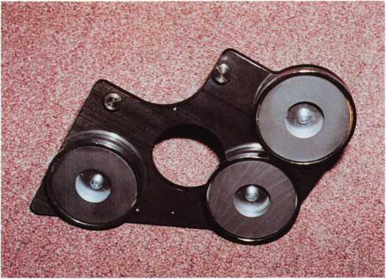

This is the basic setup for the main bracket. Each magnet is held in place by a screw. This makes it easy to readjust when needed. The half curve has a couple of “feet” that help in leveling the unit.

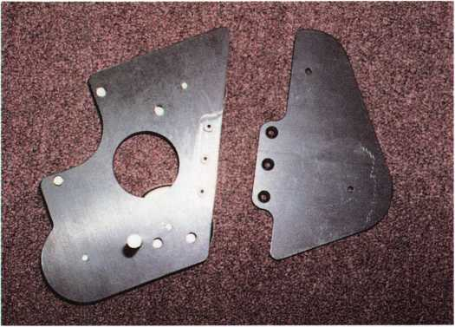

Sometimes, a safe's escutcheon prevents the basic bracket from holding the unit effectively. The addition shown here is part of the kit and can be used to extend the basic unit which will allow for better attachment to a safe door.

November 1999

Keynotes

STRATTEC 200CTWBATE

**part oi\ry**

**by Sal Dulcamara, CML**

At the recent ALOA show in Cincinnati, one of the classes I took was STRATTECs auto update for 1999-2000. The class highlighted a number of changes for the 2000 car model year, while reviewing the various designs in use by auto locks made by STRATTEC. It was a full day class, and I’m not going to try to fit all the information presented in the class into this article. I will instead try to provide some important and valuable highlights, plus a number of useful charts depicting car model information and tumbler arrangements for various car locks. I will only cover the big three: GM, Ford and Chrysler, in three separate sections.

**GENERAL MOTORS**

While the vast majority of GM products now make use of the 10-cut double sided key, there are a variety of lock and key variations currently in use. Very few GM cars still make use of locks that require 6-cut single sided keys. To a large extent, electronic security features are being integrated into the locks and keys. Different car models make use of different lock and security systems. My primary emphasis will be on the ignition locks and keys.

Before I get to the applications charts, I will try to explain and classify some of the types of ignition locks and keys. For some, special components or features are required by both the locks and the keys. PASSKey II, what most of us know as VATS, involves the use of a resistor pellet embedded in the neck of the ignition key. Besides the key, the ignition lock has wires that run down the steering column and contacts at the opening of the keyway. When electrical current flows through the wires to the contacts and through the resistor pellet, a special module checks the measured resistance of the pellet and allows the car to start if it’s the correct value.

PASS Key III is the ignition security system for General Motors’ vehicles that makes use of transponders. A transponder is concealed in the head (bow) of the key, while a ring shaped antenna is found at the face end of the ignition lock. The antenna receives a signal from the transponder key which identifies it. A device in the vehicle processes the information to determine if the key had been programmed into the system to allow the ignition to start. In the charts under the column “Security,” PASSKey III systems will be identified as“RFID”.

A third ignition security system is called PASSLock. Unlike either of the two previously mentioned systems, it does not involve any special components inside the key. In the charts, it will be identified as “MRD.” It works when a magnet contained within the cylinder plug passes a sensor inside the lock case or shell during key rotation. As long as a properly cut key is used and the plug turns, the car will start. This type of system is not designed to stop the usage of unau­thorized duplicate keys. It is designed to prevent the ignition from starting when force is used to turn the plug without a properly cut key. If force is applied, the magnet will break during plug rotation.

If an intact magnet fails to pass under the sensor, the vehicle will not start.

Two charts will identify the ignition security systems and some other information for 2000 model GM products. One chart will be for passenger vehicles and the other for trucks and vans. The first

**22** I **Keynotes** **November 1999**

column will identify body type. The next two columns will tell make and model. Next is the security system used. The following are equivalents. VATS = PASSKey II. MRD = PASSLock. RFID = PASSKey III. “M/P” indicates the master or primary (ignition) key blank used, and “V/S” tells the valet or secondary key blank. The numbers used are STRATTEC numbered groove patterns. “Column” will identify how the ignition lock is attached. “Tumbler Chart” will refer to another set of charts that identifies the tumbler locations.

The security system, mentioned earlier, does not automatically coincide with a specific column designation. All three security types will be found on two or more different ignition lock mounting designs. There are four different column designations: Standard, Modular, CSS and Modular ID. The standard column is the one used for for older style ignition locks that have 6-cut single sided keys. Modular indicates a lock that uses a 10-cut double sided key.

Removal of the steering wheel (or air bag) is normally not required to gain access to the lock. When servicing, the whole lock will come out. CSS identifies a variation of the original modular design. Only the lock plug is removed for standard servicing or key fitting. A quick visual identification of the two types can be made if you think of the steering wheel like a clock face. The CSS column has the ignition lock mounted higher or above 3 o’clock. The normal modular style has the lock mounted lower or below 3 o’clock.

Of the four ignition lock types, the three mentioned above are actually mounted to the steering column. Modular ID is not actually a steering column mounted design. “ID” stands for “in-dash.” It is a modular 10-cut style, but that ignition lock is mounted in the dash board. Like the modular designation above, the whole lock must be removed for servicing. The plug alone cannot be removed like the CSS column.

Before I get into the ignition lock application charts,

I want to call attention to some changes for the 2000 model year. STRATTEC is not the only lock maker for GM vehicles. The chart in Figure 1 indicates a number of 2000 model GM cars that don’t use STRATTEC locks. Some models have been discontinued and others have changes in the body type designations. You may need to pay closer attention to key codes for GM vehicle locks, as there will be STRATTEC key codes and different codes for locks made by other manufacturers.

The charts in Figures 2 and 3 will only give lock and key informa­tion for GM vehicles with locks made by STRATTEC. The only cars that still use the 6-cut single sided keys are the Chevrolet Lumina and Camaro and the Pontiac Firebird/Trans Am. They all have the standard steering column ignition lock mount and VATS (PASSKey) security format. The only other places you see VATS security is in the Buick Century and Regal with the CSS style column lock, and the Corvette with and in-dash style modular ignition lock. They use the double sided 10-cut style VATS keys. The chart in figure 2 indicates that the vehicles with the modular style column lock all use MRD security. Modular in-dash ignition locks come in two different security versions: MRD (PASSLock) and VATS (PASSKey II) for the Corvette mentioned earlier. All the trucks and vans, identified in

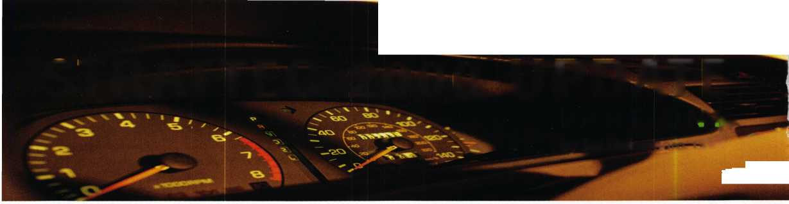

ASSOCIATED LOCKSMITHS OF AMERICA, INC.  
MEMBERSHIP APPLICATION

Welcome to the Associated Locksmiths of America, Inc., an association for persons involved in the security industry a  
locksmiths, security consultants, educators, manufacturers, or distributors.

To apply for membership, please complete this application and submit it with the application fee, dues for the currenl  
year, and your business card, company letterhead, or suitable proof of employment.

All of the following questions MUST be answered before this application may be processed. Please type or print.

TYPE OF MEMBERSHIP

Please check only one.

* ACTIVE MEMBERSHIP Individuals have actively engaged in supplying, servicing, or  
  installing security hardware for a period of not less than two years.
* APPRENTICE MEMBERSHIP Individuals who are in initial training and meet all the  
  requirements for Active Membership except for the length of time in the security industry.
* ALLIED MEMBERSHIP Individuals whose position in the security industry relates to  
  the aims, policies and promotion of the locksmith and his/her craft.

CANDIDATE INFORMATION

Name: MR. MRS. MS. [circle one)

Business Name:

Business Address:

City: State: Zip Code+4:

Work Phone: Home Phone:

Home Address: __

City: State: Zip Code+4:

Social Security Number: Date of Birth:

Send mail to: □ Business □ Home

Directory Listing □ Business □ Home □ None

APPLICATION AND FEES

A $40 application fee, appropriate annual due and your business card, company letterhea< or suitable proof of employment mu* accompany this application. Dues includ $25 subscription to Keynotes monthly magazim Your second year's dues will be prorate based on the date your application wa received by ALOA.

Be sure to include appropriate fees  
and information:

* Letterhead, business card,

or other proof of employment

* Application Fee $ 40.00

ANNUAL DUES:

* Active/Allied Member $125.00
* Apprentice Member $ 75.00

OTHER FEES:

* Canadian Air Mail $ 20.00
* Overseas Air Mail $ 50.00

PROFESSIONAL INFORMATION

TOTAL ENCLOSED $

Are you a: □ Sole Owner □ Corporate Officer □ Partner □ Employee □ Student  
Are you currently engaged in the security industry?: □ No □ Yes,years  
How did you learn locksmithing or security work?

Are you a member of a local locksmithing association? □ No □ Yes

If “Yes,” please provide name and address of association[s):

METHOD OF PAYMENT

* Check [payable to ALOA in U.S. funds)
* MasterCard □ VISA
* Discover □ American Express

ALOA Member SponsorALOA #

Please note, if you are sponsored by an ALOA member, your application will be immediately processed with  
a 90 day probation period. Otherwise, final processing takes up to 120 days.

Names and addresses of two industry-related references [required):

Card Number

Expiration Date

Please print name as it appears on card

Cardholder’s Signature

IMPORTANT!

Have you ever been convicted of a felony?

* No
* Yes (If “Yes", please give details on a separate sheet.

All felonies are reported to the Membership Committee for review)

/ certify that all statements are true and, if accepted as a member, / agree to abide by the rules,  
regulations, and Bylaws of ALOA, and further agree to adopt the Code of Ethics of ALOA as my own,  
and adhere to it to the best of my ability. Should my membership be discontinued, I agree to return  
my membership card, and cease use of all ALOA insignia.

Date

FOR OFFICE USE ONLY

AMOUNT RECEIVED

APPLICATION FEE

DUES

RECEIVED BY

APPRENTICE TRANSFER

NUMBER

DATE RECEIVED

DATE APPLIED ____

APPLICANT LISTED

IN KEYNOTES

Signature

Mail or fax completed form and payment to. Associated Locksmiths of America, Inc., 3003

Live Oak Street, Dallas, Texas 75204; FAX 214.827.1810

10.9

figure 3, use the CSS column. For all of them, security is either MRD or RFID.

Although all the double sided keys are 10-cut style, there are variations in the locations of the tumblers in the various locks. When trying to fit a key, it is useful to know how the tumblers are arranged so you can decide which and how many locks are needed to make a working key. The last column for both charts, in figures 2 and 3, identifies another separate set of charts to identify the tumbler positions for particular car models. The letter found in that column identifies the appropriate lettered chart in figure 4.

Except for VATS, you don’t need special electronic equipment for programming or making working keys. When locksmiths hear the word transponder, many tremble and have visions of little electronic boxes that cost more than $1,000. While true for many transponder security systems, it doesn’t yet apply to most GM.

GM still holds the largest share of the auto market, and you can fit a GM transponder key without a big outlay of dollars.

{Editor’s note: Next month, we conclude this article *by* examining Chrysler *and Ford.)*

Note: VATS = PASSKey II MRD = PASSLock RFID = PASSKey III

|  |  |  |  |
| --- | --- | --- | --- |
| Figure 1. | 2000 GM Changes/Additions | | |
| MAKE | MODEL | PREVIOUS | 2000 |
| Buick | LeSabre | H-Body | Not Strattec |
| Pontiac | Bonneville | H-Body | Not Strattec |
| Oldsmobile | 88 | H-Body | Discontinued |
| Cadillac | Deville | K-Body | Not Strattec |
| Cadillac | Eldorado | E-Body | Not Strattec |
| Chevrolet | Suburban | CK | GMT-830 |
| GMC | Suburban | CK | GMT-830 |
| Chevrolet | Yukon | CK | GMT-820 |
| Chevrolet | Tahoe | CK | GMT-820 |
| Chevrolet | Monte Carlo | W-Body | GMX-230 |
| Chevrolet | Impala | New | GMX-210 |
| Buick | Riviera | G-Body | Discontinued |
| Oldsmobile | Aurora | G-Body | Discontinued |
| Oldsmobile | Cutlass | W-Body | Discontinued |
| Oldsmobile | Intrigue | W-Body | GMX-170 |
| Chevrolet | Malibu | W-Body | P-90 |

|  |  |  |  |  |  |  |
| --- | --- | --- | --- | --- | --- | --- |
| Figure 4. GM 10-Cut Tumbler Positions  CHARTA  LOCK 1 2 3 4 5 6 7 | | | | 8 | 9 | 10 |
| Ign. X | X | X X X X | X | X | X |  |
| Door |  | X | X | X | X | X |
| RC/TC |  | X | X | X | X | X |
| IP |  | R | X | X | X | X |
| LOCK 1 | 2 | CHART B  3 4 5 6 | 7 | 8 | 9 | 10 |
| Ign. X | X | X X X X | X | X | X |  |
| Door |  | X | X | X | X | X |
| RC/TC |  | XXX | X | X | X | X |
| IP |  | R | X | X | X | X |
| LOCK 1 | 2 | CHARTC  3 4 5 6 | 7 | 8 | 9 | 10 |
| Ign. X | X | X X X X | X | X | X |  |
| Door  RC/TC |  | X X X X XXX | X  X | X  X | X  X | X |
| IP |  | R | X | X | X | X |
| LOCK 1 | 2 | CHART D  3 4 5 6 | 7 | 8 | 9 | 10 |
| Ign. X | X | X X X X | X | X | X |  |
| Door |  | X | X | X | X | X |
| RC/TC  IP |  | R | X | X | X | X |
| Stowage  LOCK 1 | 2 | CHARTE  3 4 5 6 | X  7 | X  8 | X  9 | X  10 |
| Ign. X | X | X X X X | X | X | X |  |
| Door |  | X | X | X | X | X |
| RC/TC |  | X | X | X | X | X |
| IP  LOCK 1 | 2 | CHART F  3 4 5 6 | 7 | 8 | 9 | 10 |
| Ign. X | X | X X X X | X | X | X |  |
| Door |  | X | X | X | X | X |
| RC/TC  IP  LOCK 1 | 2 | CHART G  3 4 5 6 | 7 | 8 | 9 | 10 |
| Ign. X | X | X X X X | X | X | X |  |
| Door |  | X | X | X | X | X |
| RC/TC |  | X | X | X | X | X |
| Spare Tire |  | X | X | X | X | X |

|  |  |  |  |  |  |  |  |
| --- | --- | --- | --- | --- | --- | --- | --- |
| Figure 2. GM Vehicle Key & Security Systems | | | | | |  |  |
| BODY | MAKE | MODEL | SECURITY | M/P | M/S | COLUMN | TUMBLER |
|  |  |  |  |  |  |  | CHART |
| W | Buick | Century, Regal | VATS | 75P | 75S | CSS | B |
|  | Pontiac | Grand Prix | RFID | 88M | 75V | CSS | A |
|  | Chevrolet | Lumina | VATS | 50A | 57H | Standard |  |
| GMX-170 | Oldsmobile | Intrigue | MRD | 88 |  | Modular ID | C |
| J | Chevrolet | Cavalier | MRD | 75 |  | Modular | C |
|  | Pontiac | Sunfire | MRD | 75 |  | Modular | C |
| P-90 | Chevrolet | Malibu | MRD | 75 |  | Modular ID | C |
| GMX-130 | Oldsmobile | Alero | MRD | 75 |  | Modular ID | C |
|  | Pontiac | Grand Am | MRD | 75 |  | Modular ID | C |
| GMX-210 | Chevrolet | Impala | MRD | 75 |  | Modular ID | c |
| GMX-230 | Chevrolet | Monte Carlo | MRD | 75 |  | Modular ID | c |
| Y | Chevrolet | Corvette | VATS | 75 |  | Modular ID | D |
| F | Chevrolet | Camaro | VATS | 50A | 57H | Standard |  |
|  | Pontiac | Firebird/Trans Am | VATS | 50A | 57H | Standard |  |

|  |  |  |  |  |  |  |
| --- | --- | --- | --- | --- | --- | --- |
| Figure 3. GM Tmck/Van Key & Security Systems | | | | | |  |
| BODY | MAKE | MODEL | SECURITY | M/P M/S | COLUMN | TUMBLER  CHART |
| GMT-800 | Chevrolet | PickUp | MRD | 75 | CSS | F |
| GMT-800 | GMC | PickUp | MRD | 75 | CSS | F |
| GMT-820 | Chevrolet | Tahoe | MRD | 75 | CSS | E |
| GMT-820 | GMC | Yukon | MRD | 75 | CSS | E |
| GMT-830 | Chevrolet | Suburban | MRD | 75 | CSS | E |
| GMT-830 | GMC | Suburban | MRD | 75 | CSS | E |
| G | Chevrolet | Full Size Van | MRD | 75 | CSS | E |
|  | GMC | Vandura/Rally | MRD | 75 | CSS | E |
| LM | Chevrolet | Astro | MRD | 75 | CSS | E |
|  | GMC | Safari | MRD | 75 | CSS | E |
| ST | Chevrolet | S-10 PickUp | MRD | 75 | CSS | F |
|  | Chevrolet | S-10 Blazer | MRD | 75 | CSS | G |
|  | GMC | Jimmy | MRD | 75 | CSS | G |
|  | GMC | Sonoma | MRD | 75 | CSS | F |
|  | Oldsmobile | Bravada | MRD | 75 | CSS | G |
| GMT-425 | Cadillac | Escalade | MRD | 75 | CSS | E |
| U | Chevrolet | Venture | RFID | 75 | CSS | A |
|  | Oldsmobile | Silhouette | RFID | 75 | CSS | A |
|  | Pontiac | Transport | RFID | 75 | CSS | A |

November 1999

Keynotes

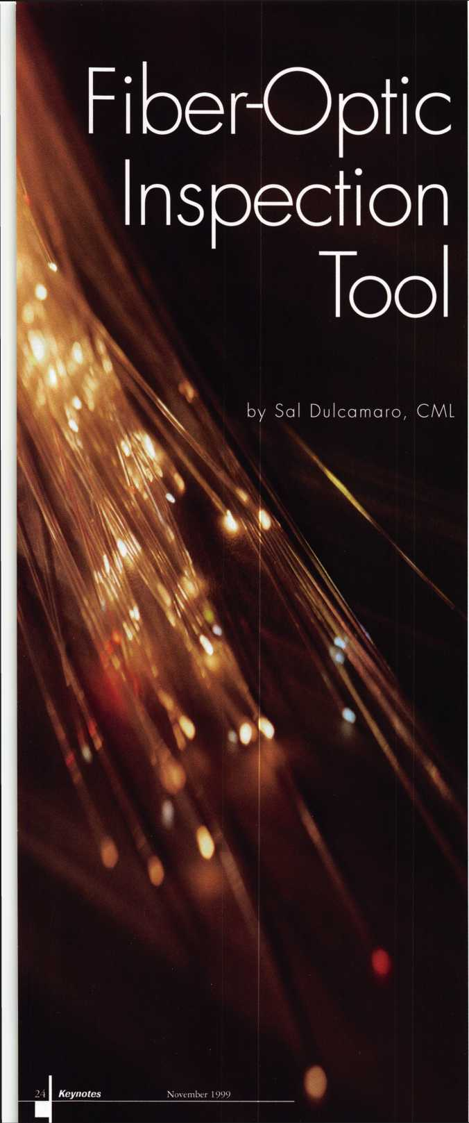

Recently, I came across a rather interesting product that might prove useful for many locksmiths. It is a fiber-optic inspection tool from a company called Dutchguard, out of Kansas City,

Mo. The product literature doesn’t identify the product with our profession, but I can see quite a few useful applications for people in our business. Photo 1 shows the tool called the Provision 100. It has a flexible 18 inch cable which will stay in the shape to which you flex it.

The yellow roll ring near the eye piece, in photo 2, allows you to focus from a fairly wide field of view to extremely close up. Photo 3 shows the tip end of the tool. The fiber optic lens is the one in the upper right position of the three circles. The other two circles are set up to send light through the cable to brighten whatever you are viewing through the lens. In photo 4,1 am pushing the yellow switch that turns on the light. The two circles are lighted in the tip of tool, in photo 5. The 18 inch cable can be submerged in water without harm as the lens is sealed. The handle with the eye piece and battery compartment cannot be submerged in water. Also, although the cable will work under water, it should not be placed in environments where it will come in contact with caustic chemicals, fuel or other liquids.

Let Me Count the Ways

The Provision 100 is a versatile device, and the variety of circumstances where you might be able to use it are limited only by your imagination. The cable is a hair under a half inch in diameter. If you want to slide it through an opening to view something in an awkward place, you must keep the size limitation in mind. The cable is very flexible and can be contorted in numerous shapes. A severe or sharp corner bent into the cable, however, could damage it.

The wide range of focusing is quite impressive. You can focus on a group of things many feet away from the tip of the tool, or something just a fraction of an inch away. The lens does not magnify. If you wish to try to read a code number stamped on a lock body inside a door panel, you will need to bring the tip of the tool right up to the object. It can focus precisely enough that you can read a small stamped number.

If you prefer to get a wider view of the internal layout of the door panel, it is possible to view the

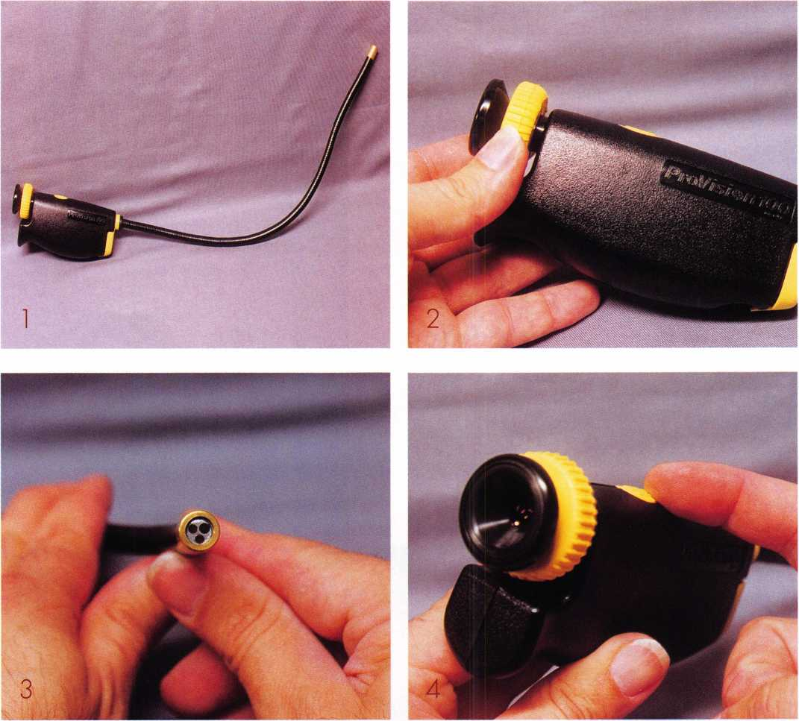

scene with the lens, but you may need additional light. The light built into the tool will only throw a short distance and will work fine to brighten a small object that you are approaching very closely with the tip of the tool. When you try to view something at a greater distance, the lens is capable of focusing on it if you can somehow throw enough light in the area.

If you have a fairly bright inspection light available, you should probably be able to provide enough light to get a much wider view of the linkage or mechanism inside. Account for the thickness of the cable. Many doors will allow you to spread a half inch gap between the window and

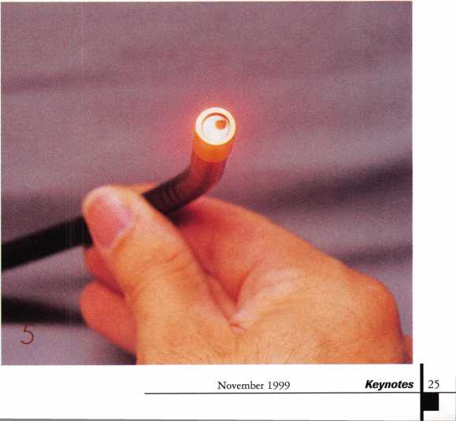

frame, but quite a few others are much tighter and attempting to spread the gap large enough could cause damage. Use common sense.

I know that a number of import autos have code numbers (sometimes integrated into a larger series of digits) stamped somewhere on the ignition lock body. In some cases, a shroud might have to be removed or at least loosened. In certain situations, the Provision 100 might be able to save you some cramps and back aches. The fiber-optic inspection tool may give you the ability to sneak a peak in a relatively awkward and cramped position, without having to try to maneuver about upside down and squeeze your head into a tight spot under a dash board or steering column.

If you are moving the lens very closely to small objects in an obstructed location, you will have to practice steering the end of the tool. Sometimes the objects you are looking at are somewhat unfamiliar. When trying to find the thing you want, you may not be able to place whether you are above, below, to the left or to the right of the object. Although the

cable is flexible, it will stay in the shape that you bend it.

You don’t have to worry about it drooping out of your intended line of sight.

I was unable to photograph the view through the eye piece of the Provision 100. It is much clearer to your eye through the eye piece, than I could photograph. But I assure you it gives a clear and detailed view.

As I mentioned earlier, the possible uses for the fiber-optic inspection tool are limited only by your imagination. It seems like a rather handy and useful tool. If you would like additional information about the Provision 100, contact: DutchGuard, 412 W. 10th St., Kansas City, MO 64105.

Phone: 816/221-3581. Toll free: 800/821-5157.

FAX: 816/502-3734.

PRS TUV WXY

***NOW ON SALE!***

6120-305 Lock w/ satin chrome key pad was $134.95

*NOW $97.95*

4440,4442,4443 Safe Deposit Locks (specify hand) was $16.05

*NOW $12.95*

6730-100 - Group 2 Lock w/ D300 dial

and ring was $65.00

*NOW $49.95*

**Prices good till  
December** 23,1999

**-time Time-Master.com (web) TIMSTR@, ^ MASTER 888 798 8464 / Fax 800 798 TIME (8463)**

**[TIMSTR@aol.com](mailto:TIMSTR@aol.com) (email)**

**IE (8463) 785 232 8705 / Fax 785 232 2603**

Keynotes

November 1999

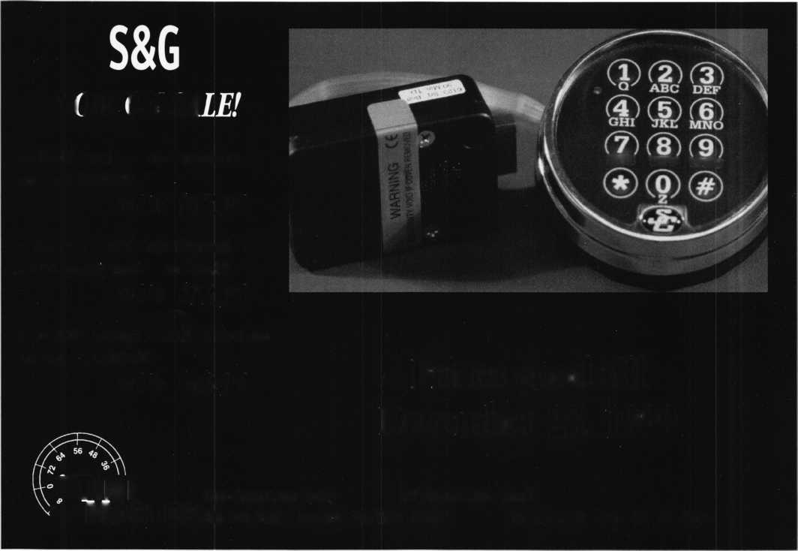

**Your FULL PATS programming**

TOOL IS NOW AVAILABLE !

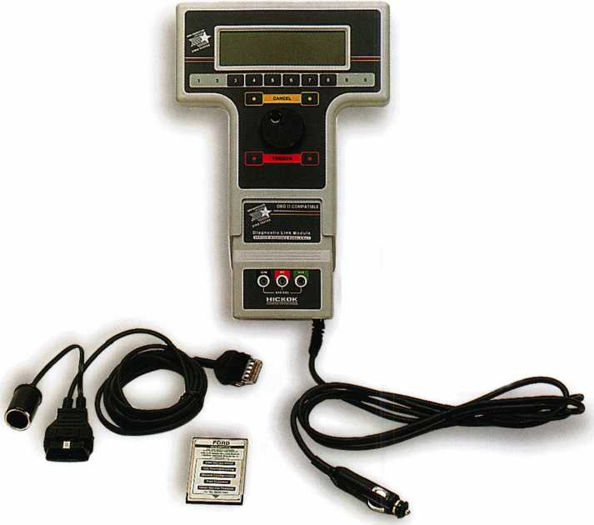

**New Generation STAR (NGS) Tester**

**(**8**OO-**8**LA)**

* Use the NGS to program keys into Ford-Lincoln-Mercury vehicles (1996 to current model year 2000) equipped with a Passive Anti-Theft System (PATS).
* The NGS kit (Model 800-8LA) contains the components to access all vehicles equipped with PATS.
* Stop sending your customers to the competition, or to the dealer when you can provide the service, make money and save the customer time.

HICKOK

INCORPORATED

Contact Hickok Inc. at (800) 342-5080  
for more information on a distributor in your area.

C.D. Lipscomb

Most schools teach you the basics and prepare you for entry level locksmithing. Then, all you have ahead of you is the rest of your life, learning the business. You will never stop learning if you are any good. Therefore, any schooling you get, is good for you. What comes under the heading of experience is what tools to buy, and what you really need to work in locksmithing

I have had many people ask me what they needed to get started. My usual smart-alec answer is: a few loose screws. After one gets those, then they have to look at getting tools. At right is a basic list, in no particular order of importance, of the things that all locksmiths have a need for. This is pretty much a minimum compliment of tools for someone doing general work.

A specialist, or an employee assigned to doing just a few things may not need every one of these things but generally these are the basic tools that all locksmiths need to work with.

There is just no end to this list of tools. This could run pages and pages. The list shown here is what I consider to be an average compliment of basic locksmith tools that a person would have accumulated after a short time, if he was well equipped. This is a minimum of what a self-employed person needs, and this is just hand tools. After a person has been working for a while, he, or she will have accumulated quite a bit more than this.

After this, you get into the specialized tools for the type locksmithing that you are going to do. Each field of locksmithing has its own tools. Most of the larger, more expensive ones will be furnished by your employer.

The different areas are Car openings, Residential, Commercial, Industrial, Automotive, Electronic, Detention, Safe Deposit, Bank, Safe, Vault, Furniture, and Old Locks.

Each of these areas have tools peculiar to them with a similar long list that you may or may not be able to use elsewhere. As you can see, just having the basics will be expensive. When you set out to do a little of everything, be prepared to spend a great deal of money.

This has not even begun to address the key machines needed. This depends on where you go in locksmithing. Locksmithing costs as much or more to get into as any other craft. It is not unusual for a locksmith who does general work, and is set up to do everything, to have 30 to 40 thousand dollars worth of tools and supplies and still not have it all. That doesn’t include stock.

I hope that this article is helpful in letting you know what kind of tools you need to get started in this business.

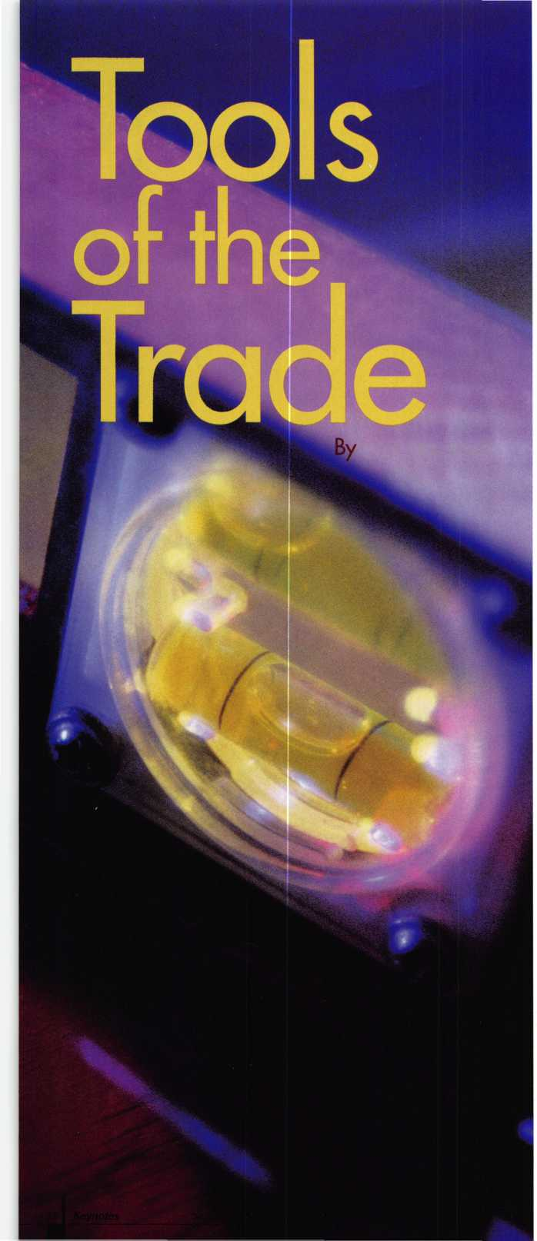

A Locksmith's Checklist

As for your tools, you should get a good idea of the hand tools that  
you need for basic stuff in class. A basic list is going to consist of:

(in no particular order of importance)



* A good set of screwrivers, from jeweler's flat and Philips to up to large flats and #3 Philips. A really good set, like Craftsman, is the cheapest thing you can buy in the long run.
* Several sizes of pliers from small to large, including needle nose, and diagonal wire cutting.
* Internal and external snap ring pliers or a combo unit.
* A set of both metric, and SAE, wrenches and sockets.
* A 6 inch or 8 inch pippin file. I prefer #4 Gorbet
* A round impressioning file 8 inch- #4 Gorbet
* A small Warding file
* A 6 inch and 10 inch Mill Bastard flat file.
* A good hand tool boxes.
* A good set of wood chisels, Stanley or better.
* A good sharpening stone to keep the chisels sharp.
* A case or canvas carrying pouch to keep the chisels in to keep them from getting dull in the tool box.
* A utility razor knife, the kind with retractable, disposable blades.
* A 12 foot measuring tape.
* A 6 inch dial, or electronic digital caliper capable of reading to .001 inch. (Tip: grind the male end that extends out on the end to where it will go down into a pin hole for measuring the depth of pin needed.)
* A set of plug followers, both solid, and hollow. Get the hollow, if you can only get one type. You will need several sizes. There is a set sola that has all the popular sizes in it.

CH A .500 inch combination plug follower that will dump top pins, as made by Keedex, or others.

* A cylinder cap removal tool for Weiser, Weiserbolt, and Schlage locks.
* A Kwikset Tool
* A small sharp pointed scribe. Many use an ice-pick for this.
* A set of key depth gauges. Keedex makes a good one with Kwikset, Schlage Weiser, and Dexter, but you will need as many different ones as you can get, like Yale, etc.

CD A set of cap removal pliers. Even though this is an automotive tool, it is priceless for all parts of locksmithing.

CH 4 inch or 5 inch vice grip pliers for impressioning.

* An impressioning handle, as sold by Pro-lock, Framon, and others. They are so much easier that they are worth it.
* A set of basic picks. (You do not need the 100 piece pick set that weighs a ton, and has picks that only Houdini would ever use.) A nook, double rake, diamond, ball, double ball, deep hook, and several sizes, large to small turning bars, is enough to start with.
* A tubular pick. HPC makes a good one. (damn, this list is getting long).
* A manual pickgun, (E-Z, Majestic, Life-aid, or the like.) You are going to have to make friends with what ever you get, anyway. You may have to go through more than one to get one that is right for you.
* A set of HSS drills bits, from 1/16 inch to 1 /2 inch by increments of 1 /16 inch with drill index.
* A 3/8 inch variable speed industrial duty drill. Get the best one you can afford. Having a built-in leveling bubble on it is a plus.
* A 6 inch torpedo level.

[□ A 30 inch level

* A 1 /2 inch Industrial Duty Hammer Drill with a hammer on/hammer off selector switch. A variable speed/two speed is a plus. Again, the best that you can afford is the cheapest in the long run.
* A set of concrete/masonry bits from 1 /8 inch to 1 inch by 1/16 inch increments.
* A 13 oz. claw hammer.
* A small ball peen hammer.
* A large ball peen hammer.
* A small brass locksmith's hammer.
* A set of good quality cold chisels

[□ A 9.6v (or higher) variable speed rechargeable battery powered drill with 11 Ov charger, and 12v. charger.

* A set of driver bits for the battery powered drill with magnetic drivers, and extended length bits in flat, #2 & #3 Phillips bits.
* A tool apron or tool belt similar to a carpenter's Belt, with an electrician's type pouch. A set of suspenders for this belt is good when you have to wear it on the job all day.

[□ A hard hat, gloves, Safety glasses, and safety shoes. You will go onto jobs where they will require all of these, just to get in the gate.

* A uniform. Preferably, matching dark blue work clothes. Grease and graphite stains do not show up that much on dark blue. Plus, work clothes don't tear as bad as regular garments. It is a matter of economics. Uniforms may or may not be provided by your employer but even if not, it is the best way for you to go. It tends to set you out ahead of the rest. A person that looks unprofessional, probably is that kind of workman, too. Looking good will tend to get you hired, whether it is an employer or customer. Looking neat and well groomed gives you an edge with the customers too.
* A good set of key extractors including several spiral tools.
* A set of dental picks of several different shapes for probing.
* A Downey pin or large upholstery pin, or a straight probe made of wire. Actually, several different diameter wire probes, made of music wire would be the best.
* A set of torx drivers, the kind with plastic screwdriver type handles.
* A set of tamper resistant bits with handle including several different shapes like tamper proof torx, tamper proof alien, and others. Sets of these are available from various screw vendors.
* A set of ball end, SAE and Metric Allen wrenches, from very small to very large (1 /2inch or so).
* Tool boxes to hold all this stuff, preferably one that you can lock up. You will lose more dollars worth of tools to people working with you borrowing them, than to any thief.

November 1999

***Keynotes***

Legislative Update

i

by Tim McMullen

j

**j**

VIA FACSIMILE (202) 268-5211

Mr. William J. Henderson Postmaster General and CEO United States Postal Service 475 LEnfant Plaza, SW Washington, DC 20024

Dear Mr. Henderson:

My name is XXX, a locksmith in XXX. I am writing you today because of a grave concern I have regarding what I considered a misinterpretation of the Mail Order Lock Pick Prohibition Act. This law is codified in 39 USC 30 33002a and 18 USC 83 31716A.

I am also a member of the Associated Locksmiths of America, Inc., which has reported to the U.S. Postal Inspection Services in Newark, New Jersey, St. Paul, Minnesota and San Francisco, California of people selling lock picks and lock picking devices through the mail. Unfortunately, these inspection service departments find no violation of this federal statute because the material in question was being mailed by means other than the USPS.

However, the statute clearly states, ‘Whoever knowingly deposits for mailing or delivery, causes to be delivered by mail, or causes to be delivered by any interstate mailing or delivery other than by the United States Postal Service, any matter declared to be nonmailable by section 3002a of title 39, shall be fined under this title, imprisoned not more than one year, or both.” (emphasis added).

To me, this would mean that anyone who mails lockpicking devices interstate to any non-authorized party regardless of carrier would be in violation of the law.

I ask that you take another look at the law based upon this analysis. I am concerned that lock pick tools are continuing to be sold through the mail to persons other than qualified locksmiths. This is a tremendous threat to the general public as well as the integrity of the profession. Thank you in advance for your immediate attention to this matter.

ALOA TAKES ON  
THE POSTMASTER  
GENERAL

All locksmiths should know that selling  
lockpicking tools using any type of interstate  
mail service to deliver that item is a violation  
of federal law, unless there is an exemption.  
The text of the law reads:

39 USC 30 R3002a.  
Nonmailability of locksmithing  
devices

1. Any locksmithing device is nonmailable  
   mail, shall not be carried or delivered by  
   mail, and shall be disposed of as the Postal  
   Service directs, unless such device is mailed to:
2. a lock manufacturer or distributor;
3. a bona fide locksmith;
4. a bona fide repossessor; or
5. a motor vehicle manufacturer or dealer.
6. For the purpose of this section, “locksmithing  
   device” means—
7. a device or tool (other than a key)  
   designed to manipulate the tumblers in  
   a lock into the unlocked position  
   through the keyway of such lock;
8. a device or tool (other than a key or a  
   device or tool under paragraph (1)  
   designed for the unauthorized opening  
   or bypassing of a lock or similar  
   security device; and
9. a device or tool designed for making an  
   impression of a key or similar security  
   device to duplicate such key or device.

18 USC 83 IS1716A,

Nonmailable locksmithing  
devices and motor vehicle  
master keys

1. Whoever knowingly deposits for mailing or  
   delivery, or knowingly causes to be delivered  
   by mail according to the direction thereon, or  
   at any place to which it is directed to be  
   delivered by the person to whom it is  
   addressed, any matter declared to be  
   nonmailable by section 3002 of title 39,  
   shall be fined under this title or imprisoned  
   not more than one year, or both.
2. Whoever knowingly deposits for mailing or  
   delivery, causes to be delivered by mail, or  
   causes to be delivered by any interstate  
   mailing or delivery other than by the United  
   States Postal Service, any matter declared to  
   be nonmailable by section 3002a of title 39,  
   shall be fined under this title, imprisoned not  
   more than one year, or both.

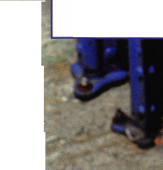

ALOA receives at least two communications a month from members who find some company’s catalogue in violation of this law, or some person selling lockpicking tools via an internet auction. In response, ALOA sends the business or person notice that they are violating the law, and copy that letter to the Postal Inspection Service for that region. What you would think (hope) would bring swift action by the federal government has been just the opposite.

We received an eighteen word letter from three of the five Postal Inspection Services that, “After a careful review of the information provided, we find no violation of federal statutes under our jurisdiction.” The key word is “jurisdiction.” ALOA followed up with phone calls to each Postal Inspector and was given the same answer, “the reason behind this response is that the material in question is being mailed by means other than the USPS.” In fact they were correct, the companies we filed the complaint against use UPS as their mail delivery service. However, ALOA has argued repeatedly that the statute clearly states, “(b) Whoever knowingly deposits for mailing or delivery, causes to be delivered by mail, or causes to be delivered by any interstate mailing or delivery other than by the United States Postal Service, any matter declared to be nonmailable by section 3002a of title 39, shall be fined under this title, imprisoned not more than one year, or both.” (emphasis added).

Having run into a wall, but not to be turned away, ALOA began a major campaign to educate the United States Postmaster General.

We kicked off this drive at the ALOA Convention in Cincinnati with faxes from members letting the Postmaster General know that this is a tremendous threat to the general public as well as the integrity of the profession. How can you help? Using the form letter on the previous page as your guide, write to the Postmaster General and let him know how you feel about the unenforcement of this law Thank you in advance for your help in putting some teeth into this law.

ACTIVE LEGISLATION

See ALOA website for links to the text of the bills.

IOWA

H310

SUMMARY: Provides for the mandatory licensure of alarm system

businesses by the department of public safety, and makes many  
of the provisions of Code chapter 80A, which applies to the  
licensing of private investigative agencies and security agents,  
applicable to an alarm system business.

STATUS:

02/18/1999 INTRODUCED.

02/18/1999 In HOUSE. Formerly HOUSE File 203. 02/25/1999 In HOUSE. Filed Amendment No. 1036. 03/01/1999 In HOUSE. Adopted Amendment No. H 1036

(EXEMPTION FOR LOCKSMITHS)

07/09/1999 78th General Assembly—First Session Adjourned 04/29/1999 Carried Over to 78th General Assembly- Second Session.

ILLINOIS

H1296

SUMMARY: Makes technical changes in the Section concerning unlawful acts in the Private Detective, Private Alarm, Private Security and Locksmith Act of 1993.

STATUS: 02/17/1999 INTRODUCED.

03/05/1999 Rereferred to HOUSE Committee on RULES.

H621

SUMMARY: Provides that police, fire, or other municipal employees may open a lock when a diligent effort has been made to contact a licensed locksmith who can provide the service in a timely manner as determined by the police, fire, or other municipal employee.

STATUS: 02/04/1999 INTRODUCED.

03/26/1999 In HOUSE. Read second time.

Adopted Amendment No. 1

03/26/1999 Rereferred to HOUSE Committee on RULES.

* House Bill 621 said that a police officer may open a lock in a life-threatening situation or when the location of a vehicle creates a danger to the public. The amendment adds, “or when a diligent effort has been made to contact a licensed locksmith who can provide the service in a timely manner as determined by the police, fire, or other municipal employee who shall take into consideration the health and safety or the occupants or the vehicle. ”

S212

SUMMARY: Makes a technical change.

STATUS: 02/03/1999 INTRODUCED.

03/11/1999 In SENATE Committee on LICENSED ACTIVITIES: Postponed in committee. 03/18/1999 In SENATE Committee on LICENSED ACTIVITIES: Held in committee.

03/20/1999 Rereferred to SENATE Committee on RULES.

S452

SUMMARY: Amends the Private Detective, Private Alarm, Private Security, and Locksmith Act of 1993; provides that an agency may employ a person under the act if the person possesses a valid permanent employee registration card or if the person has a valid license under the Act; provides that nothing in the Act prohibits police, fire, or other municipal employees from opening a lock in specified circumstances.

02/18/1999

05/06/1999

05/14/1999

05/14/1999

STATUS: 02/18/1999 INTRODUCED.

In HOUSE. Placed on Calendar Order of  
Third Reading.

In HOUSE. Recalled to second reading.

In HOUSE. Amendment No. 2 filed.

To HOUSE Committee on RULES.

05/14/1999 In HOUSE. Third Reading Deadline  
Extended to 05/21/1999-

05/21/1999 Rereferred to HOUSE Committee on RULES.  
Amendment added that, “a police officer may open a lock in a life-threatening  
situation or when the location of a vehicle creates a danger to the public, or when a  
diligent effort has been made to contact a licensed locksmith who can provide the  
service in a timely manner as determined by the police, fire, or other municipal  
employee who shall take into consideration the health and safety or the occupants or  
the vehicle.”

MASSACHUSETTS

S545

SUMMARY: Establishes a program with the Department of Housing  
and Community Development to retrofit windows with  
security bars.

STATUS: 01/06/1999 INTRODUCED.

01/06/1999 To JOINT Committee on HOUSING  
AND URBAN DEVELOPMENT.  
07/15/1999 From JOINT Committee on HOUSING  
AND URBAN DEVELOPMENT:  
Accompanied Study Order H 4545.



November 1999

NEW YORK A2099

SUMMARY: Allows for a 10% credit against income tax for businesses in

Kings County which install security systems at their businesses. STATUS: 01/20/1999 INTRODUCED.

01/20/1999 To ASSEMBLY Committee on WAYS AND MEANS.

A3889 (SAME AS: A8242)

SUMMARY: Provides that a taxpayer 65 years of age or over shall be

allowed a credit against personal income tax for the purchase and installation of a security device in his principal residence located within the state; provides that such credit is limited to 50% of the expenditure not to exceed a maximum of $400. STATUS: 02/04/1999 INTRODUCED.

02/04/1999 To ASSEMBLY Committee on WAYS AND MEANS.

A4560 (SAME AS: S2530)

SUMMARY: Makes it a class A misdemeanor to knowingly possess

equipment used to make duplicate keys under circumstances evidencing intent to use such devices to unlawfully enter or operate a motor vehicle.

STATUS: 02/11/1999 INTRODUCED.

02/11/1999 To ASSEMBLY Committee on

ECONOMIC DEVELOPMENT.

06/21/1999 From ASSEMBLY Committee on ECONOMIC DEVELOPMENT,

JOB CREATION, COMMERCE AND INDUSTRY.

06/21/1999 To ASSEMBLY Committee on CODES.

A 515

SUMMARY: Provides that class A multiple dwellings have eight or more  
apartments erected or converted prior to 1968, must have  
automatic self-closing and self-locking doors at every entrance  
from the street, roof, passageway, courtyard, cellar or other  
entrance; excludes main entrance halls and lobbies if equipped  
with automatic self-locking doors.

STATUS:

12/31/1998 PREFILED.

12/31/1998 To ASSEMBLY Committee on HOUSING. 01/06/1999 INTRODUCED.

01/06/1999 To ASSEMBLY Committee on HOUSING.

A718

SUMMARY: Permits a state income tax deduction for home security devices, including but not limited to exterior lighting, installed by the owner occupant of a one, two or three family home for an amount not to exceed $500.

STATUS: 01/06/1999 INTRODUCED.

01/06/1999 To ASSEMBLY Committee on WAYS AND MEANS.

A5684 (SAME AS: S5864)

SUMMARY: Authorizes city with a population of 1,000,000 or more to

allow credit, by local law or ordinance, against personal income tax imposed by such city, for expenses of providing security for the home, provided such structure is a 1, 2 or 3 family owner occupied residence.

STATUS: 03/01/1999 INTRODUCED.

03/01/1999 To ASSEMBLY Committee on CITIES.

A6006 (SAME AS: S3850)

SUMMARY: Establishes security requirements to be fulfilled by owners of multiple dwelling units including deadbolt locks, window pins, adequate lighting, solid core door, intercoms and optical viewers; provides requirements for each such security measure. STATUS: 03/02/1999 INTRODUCED.

03/02/1999 To ASSEMBLY Committee on HOUSING.

PENNSYLVANIA HI 23

SUMMARY: Establishes a loan program to install safety devices and improve safety at convenience stores, including gas station mini-marts. Provides for additional duties of the Attorney General. Establishes the Convenience Store Protection Fund. Makes an appropriation.

STATUS: 01/25/1999 INTRODUCED.

03/10/1999 In HOUSE. Read third time. Passed HOUSE. *****To SENATE.

03/18/1999 To SENATE Committee on COMMUNITY AND ECONOMIC DEVELOPMENT.

YES! I support ALOA in its fight against legislation that is bad for locksmithing—bad for my business!

Enclosed is my donation in the amount of: I 1 $25 CZI $35 I I $50 1 I $75 I 1 $100 I I Other $

Indicate type of funds: 1 i MasterCard 1 I Visa I i American Express CZ) Check I I Money Order

Credit Card Number: Expiration Date: /

Name (as it appears on card):

Signature:

□ Please use my donation in my state ofexclusively.

Federal law mandates that political donations are not tax deductible.

Please make checks payable to “ALOA LEGISLATIVE FUND.”

E3 Mail this completed form with your donation to:

ALOA LEGISLATIVE FUND, 3003 Live Oak Street, Dallas, TX 75204.

***Keynotes***

November 1999

Keynotes

Classified

■ EMPLOYMENT Locksmith

1 l/F/3: Company doing services for financial institutions has a great opportunity for a general-purpose locksmith to service the Seattle area. Must have vault and safe experience. Competitive salary, benefits and company vehicle provided. Clean driving record required. Fax resume to:

Attn. Grant Dr is kill (503) 670-0743

Locksmiths Wanted

10/F/3: Pittsburgh! Pittsburgh! Pittsburgh! Must have own vehicle and tools. $1,000 per week guaranteed!

Call today and ask for Mike:

(800) 926-8881 mdicieco@ interstatelocksmith. com

Locksmith Wanted

10/F/3: Locksmith wanted in Dayton, Ohio area. Top notch shop in affluent suburban community. Great sales commissions for right individual. Must be versatile, bondable and reliable. PRP status a plus. Relocation compensation for the right person.

Roger Krass PO Box 0028 Dayton, OH 45441

Locksmith Wanted

10/F/3: Immediate opening for an experienced technician in the “Land of Enchantment,” Santa Fe, New Mexico. Requirements include three years minimum experience in areas of master keying, auto lock and general field work. Good driving record essential. Salary $40-$60K plus benefits, including company equipped van and paid vacation after first year. Retirement plan also available. Send or fax resume to:

AB 1 Locksmith Service 1915 Cerillos Road Santa Fe, NM 87505 (505) 983-2690 (505) 983-3022fax



r Classified Advertising Policy

**< Classified advertising space is provided free of charge to ALOA members, and for a  
fee of $.60 per word, $15 minimum for non-members. Classified ads may be used to  
advertise used merchandise and overstocked items for sale, “wanted to buy” items,  
business opportunities, employment opportunities/positions wanted and the like.  
Members or non-members wishing to advertise services or new merchandise for  
sale may purchase a “Commercial Classified Ad,” for a fee of $1.30 per word, with a  
minimum of $40. Each ad will run for two issues. For blind boxes there is a $5 charge  
to members and non-members. All ads must be submitted in writing to the ALOA  
office by the fifteenth of the month, two months prior to issue date. Send to  
Keynotes Classifieds, 3003 Live Oak St., Dallas TX 75204-6186. ALOA reserves the  
right to refuse any classified advertisement that it deems inappropriate  
according to the stated purpose of the classified advertising section.**

Commercial Locksmith Wanted

10/F/3: ASAP Opening in Denver for a Commercial Locksmith. Safe and Access Control beneficial. Promotable opportunity. Strong salary, bonus and benefits.

(303) 893-0639fax phyllis@phillips.personnel. com

Locksmith Position Opening

10/F/3: The Kenton County Airport Board has an opening in the Building Maintenance Department for a locksmith for second shift (3 pm-1 am) Monday-Thursday. Applicant must have a high school diploma and five years working experience, with complete references available, in the trade of commercial locksmith. Applicant must have the knowledge of the materials, tasks and methods used in commercial locksmithing such as master keying, repair and installation of locksets, hollow metal doors and frames, door closers, panic devices, Simplex combination locks, electronic alarms and various other locks associated with locksmithing; the ability to use many locksmith tools; ability to prepare rough sketches of work and estimate of materials and labor; ability to carry out verbal and written directions; ability to work with others. Must be a holder of a valid operators license. Competitive salary and benefit package.

Apply in person or send resume to:

Human Resources Kenton County Airport Board P0 Box 752000 Cincinnati, OH 45275-2000

Locksmith Wanted

10/F/3: Perfect Opportunity for the right entrepreneur. Work as a locksmith for the company that could be yours. Original owner plans to sell the business within five years, so you can get to know the business while working. Inside/Outside technician needed with experience in master-keying, interchangeable cores and auto locks. Business established in 1969, consists of highly visible retail location, two well-equipped vans and four full time employees. Located in Queens, New York, we serve many commercial accounts, especially at both airports.

Fax letters of interest to:

Eric

(718)843-1717fax

Locksmith Wanted

10/P/3: Leading Louisville, KY Locksmith Company looking for experience and organi­zational skills. Offering competitive salary with bonuses, health insurance and profit sharing plan. Call and/or send resume to: Attention: Bryan Turner Willis Klein Safe, Lock, Decorative Hardware 4041 Westport Road Louisville, KY 40207 (800) 928-LOCK

Experienced Locksmith Wanted

9/F/3: Large Lock Shop in the Palm Springs area is looking for an experienced locksmith for field work. Must be proficient in Master Keying, safety deposit boxes and working knowledge of safes. Salary plus commission, health insurance benefits and 401K plan. Please fax resume to:

(760) 779-1811 or Call (760) 346-5214)

Locksmith Superintendent Wanted

9/F/3: The University of California, Los Angeles is in search of a Locksmith Superin­tendent. The person will assume full managerial and administrative responsibility for the Hardware Shop, Fire Extinguisher Shop and Tool Crib. The individual must also possess the ability to implement state of the art keying systems. Send resume to:

Experienced Locksmiths Wanted

9/F/3: A family owned business since 1959 is looking for experienced locksmiths. Must be self starters. Will pay portion of relocation. Benefits include-Medical Insurance, two weeks paid vacations, annual sick pay, IRA retirement plan, excellent wages plus commission. Send resume to:

Gene Holder

Holder’s Security Company 7027 E. 40 Th. Street Tulsa, OK 74145 (918) 6663-8660

**November** 1999***Keynotes \*** 33

Ron Guizado

UCLA Campus Human Resources rguizado@chr. ucla. edu (310) 206-1010fax

Keynotes

*Classified

Qualified Apprentice Needed

9/F/3: If you have some training as a locksmith and are willing to work hard and learn fast; and if you desire to team up with the best, then a rewarding career awaits you. We are a full service commercial security service (Locks, Keys, Safes, Alarms, CCTV and Access Controls), over 30 years in Las Vegas. We offer our full time employees an excellent compensation and benefits package, including retirement plan. Under constant training, cross training and upgrading in all skills, high incomes are common and a solid future assured. A drug test and a criminal background investigation will be required. Initial training begins in the shop, assisting a team of professionals and learning all areas of general locksmithing. Send or fax resume to: Harold Ford Ace hock & Key 1201 S. Casino Center Las Vegas, NV 89104 (702) 382-3963 fax

Security Locksmiths Wanted

9/F/3: If you are a professional Security Locksmith (CML, CPL, CRL, RL), and desire to team up with the best, then JOIN US for a most rewarding career. Our full service commercial security services include Locks, Keys, Safes, Alarms, CCTV and Access Controls. We also provide some residential and automotive work. Ace Lock-Las Vegas is a solid company with an excellent compensation and benefits package for all our team members. Constant training, cross training and upgrading in all skills generates high income and a solid future.

Send or fax resume to:

Harold Ford Ace Lock & Key 1201 S. Casino Center Las Vegas, NV 89104 (702) 382-1754 (702) 382-3963 fax

Locksmiths Wanted

9/F/3: Two locksmiths wanted to fill positions in Missoula, Mont. We need an outside and an inside service representative. We have two vans and a storefront. Prefer two years of experience and must be willing to relocate. Salary DOE plus commission possible, paid vacation and the opportunity for advancement.

Call Peter:

(406) 542-2472 (406) 542-3221 fax

|

**34 | KeynotesNovember 1999**

Locksmith Wanted

10/F/3: Chicago area mobile locksmith service seeks an experienced locksmith.

Must have own tools and car. Please call:

(708) 456-6198

Inside Sales Representative Wanted

9/F/3: Jo-Van Distributors Inc., a leading regional distributor of locksmith supplies and security hardware located in Toronto, has openings for inside sales personnel. Prerequisites include excellent organization and communication skills and trade related experience.

(416) 752-7282fax

Senior Account Manager Wanted

9/F/3: A leading company in the high security locks industry is looking for a professional sales manager with strong organization skills to fill a senior account manager position in the Los Angeles area, must have five years experience in the locksmith industry.

Please call Ron (evenings):

(310) 260-9760

Looking For A Position

9/F/3: Institutional locksmith looking for a position. CML, in Northeast area, 22 years institutional and commercial experience, networking for career opportunity with manufacturer, distributor or institutional position. Strong teaching and technical skills. Willing to relocate for the right opportunity. Resume furnished on request.

Call: (800) 532-2562 (214) 827-1810fax

Locksmith Position Wanted

9/F/3:1 am a locksmith with 11 years of experience who recently relocated to the Salem, Ore. area and I am looking for a locksmith position. I am an expert at safe-opening and I own all of my tools. For the last 11 years I worked for VSR Inc in Las Vegas; and I was the manager for the last three. I am ready to work when the opportunity presents itself. Please call Bryan:

(503) 364-5135

■ BUSINESSES FOR SALE

Business For Sale

10/F/3: Tired of the Rat Race-Here’s the ideal situation for someone who wants to raise a family in the upper Mid-West or seeks a more civilized environment and still make a living comfortably. Established in 1980, we specialize in Commercial and Institutional accounts with CCTV-High Security Locks and Access control Systems. In the heart of Wisconsin with an excellent hospital and one of the nations largest privately owned medical clinics. Downtown walk-in shop location-little competition.

(214)827-1701

Business For Sale

9/F/3: A well established, 18 years, locksmith business on a major road in Baltimore County, Maryland is for sale. Customer base includes commercial, government, automotive, auto dealers, residential and walk-in trade. Main building has a retail area, workshop area, office space and storage area on second floor. Garage building has a two bay service area. Excellent growth potential for aggressive owner. Last years gross sales were $217,000. Asking $198,000. Inquire for a list of equipment included.

Locksmith

PO Box 19018

Baltimore, MD 21284-9018

Locksmith Shop For Sale

9/F/3: Full service locksmith shop in Southern California serving the Beaumont/Banning area for over 26 years is for sale. Includes equipment, inventory, commercial accounts and a 1984 1/2 ton Ford van. 1800 sq. feet building also available for lease or sale. Owner can stay on for transition. Call weekdays for details or leave message:

(909) 845-5397

Master Locksmith Business For Sale

9/P/3: Located in East Yorkshire, England. Established for 20 years. Excellent financial track record with a large number of regular and consistent customers. Showroom, workshop, offices and trained MLA locksmiths. Available due to early retirement reasons only. Send all inquiries to:

Gamess Jones 732A Anlaby Road Hull HU4 6BP England

■ WANTED TO BUY/SELL Excess Stock For Sale

10/F/3: Large assortment of Schlage Keyblanks, both original and look-alike in these series 35- 180, 35-200, 35-100, 35-101, for sale plus an assortment of miscellaneous key blanks such as: Chicago, Illinois, Corbin and National (cam lock), ILCO (older auto), Slaymaker and misc (padlock), Yale, Ruswin, Sargent, Segal, etc. (Cylinder) and many others. I should have them cataloged soon and will send a list if you are interested. Also available is a Medeco double cylinder deadbolt lock, US 3, 2 3/4" drive in, restricted keyway, PN 11W0102 05G3- quantity 8 each, $45 each.

Call (505) 526-4106

Wanted To Buy

1 l/F/3: Wanted used 1200 HPC Machine Call: (301) 627-5876

For Sale or Trade

10/P/2: For sale or trade, door closer service equipment and parts in LCN, Corbin,

Russwin, Yale, Norton and Lockwood for $1500. Contact:

Bryan

Willis Klein Safe, Lock, Decorative Hardware (800) 928-LOCK

Tryout Keys, Depth Keys For Sale

10/P/2: Aero Lock does not use key duplicator machines to produce its tryout keys or depth keys. Only original computer controlled code cut. Buy the best.

Aero Lock

3675 New Getwell Road #9 Memphis, TN 38118 (800) 627-9433; (901) 362-1197fax aerolock@ix. netcom. com http: I Iwww. aerolock. cam

Locks For Sale

10/F/2: Marks Mortise Handle Sets 625, Schlage D & L series, Schlage F51PD Clairmont 616, Sargent Rim & KIK cylinders , Sargent Locksets, Yale Locksets, Yale Rim and KIK cylinders, Medeco cylinders Commercial 00 keyway, Medeco cylinders SKY 04 keyway, Medeco cylinders GLD Biaxial, Dexter Locksets, and Von Duprin 88EO x626. All locks are new w/ assorted keyways and finishes. If interested please call for quantity and prices.

Jennifer Renderer

(305) 944-0469

Wanted To Buy/Sale

10/F/2: Locksmtih tools and more for sale. Locksmith tools, supplies, machines, auto code cutters, code books and safe tools. Depth key sets and over 10,000 auto and domestic key blanks. Call for prices.

Emmet W. Sapp (916)391-7052

Wanted To Sell

9/F/3: Retired locksmith has several items for sale. Miles Osborne Safe $40.

Lockmasters Cutaway Lock For Manipulation, all metal mount $40. Back issues of Locksmith Ledger and National Locksmith and other items for list.

Locksmith

45055 East Florida #8 Hemet, CA 92544

Sets For Sale

9/F/3: LTI Rocker pick sets, LT340A Auto set and LT 280 GM set. Never used with instructions. $75 for both, includes shipping. CallJohn:

(203) 397-3093

**SECURITyflS**

LOCK COMPANY**flflP**

**New** Factory Replacement Parts and Locks for Security Corporation and Kumahira Safe Co. Products

* Safe Deposit Box Locks and Parts BX, KD
* Automatic Remote Tube Systems (ARTS)
* Drive Up Systems
* Vault Doors
* Night Depositories
* Camera Systems
* Key Blanks and
* Keys Cut to Code

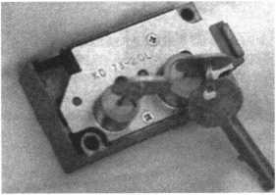

KD Series

Safe Deposit Box Locks

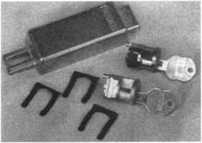

BX Series Safe Deposit Locks

1155 Chess Drive, #114 Foster City, CA 94404 Phone: (650)525-0660 Fax: (650) 525-0444

Email:

[chaslutz@securitylockco.com](mailto:chaslutz@securitylockco.com)

SECURITyfi

LOCK COMPANY HP

November 1999 **Keynotes**

Associate

Members



|  |  |
| --- | --- |
| Manufacturers | Arrow Lock Company  10300 Foster Avenue  Brooklyn, NY 11236 (718) 257-4700; FAX (718) 649-9097 |
|  | sees |
| A & B Safe Corp.  171 S. Delsea Dr.  Glassboro, NJ 08028 (800) 253-1267; FAX (609) 863-1208 | Auto Security Products (A. S. P.)  P.O. Box 10  Redmond, WA 98073-0010 (425) 556-1900; FAX (425) 558-1205 |
| esse | • • |
| ASSA Inc.  10300 Foster Ave.  Brooklyn, NY 11236 (800) 235-7482; FAX (718) 257-2772 | BWD Automotive  900 Ravenwood Dr.  Selma, AL 36701  (334) 874-9001; FAX (334) 874-6011 |
| • | • • |
| Abus Lock Company  3555 Holly Lane North  Plymouth, MN 55447-0507 (800) 352-2287; FAX (612) 509-9939 | Chicago Lock Company  10100 88th Ave.  Pleasant Prairie, Wl 53158-0069 (800) 445-3204; FAX (414) 947-7178 |
| • | e |
| Adams Rite Manufacturing Co.  P.0. Box 1301  LaPuente, CA 91749-1301 (562) 699-0511; FAX (562) 699-5094 | Corbin Russwin Architectural Hardware  P.O. Box 25288  Charlotte, NC 28229 (800) 543-3658; FAX (800) 447-6714 |
| sees | • • • • |
| Adesco Safe Manufacturing Co.  web: [www.adesco.com](http://www.adesco.com) email: [sales@adesco.com](mailto:sales@adesco.com) (800) 821-6803; FAX (562) 408-6427 | Curtis Industries  6140 Parkland Blvd, Ste. 300  Mayfield Heights, OH 44124-4103 (800) 555-5397 |
| • | • €> |
| Adrian Steel Company  web: [www.adriansteel.com](http://www.adriansteel.com)  Adrian, Ml 49221  (800) 677-2726; FAX (517) 265-5834 | DETEX  302 Detex Dr.  New Braunfels, TX 78130 (800) 729-3839; FAX (830) 620-6711 |
| • | sses |
| Alarm Lock Systems, Inc.  345 Bayview Ave.  Amityville, NY 11701 (800) ALA-LOCK; (516) 789-3383 | Don-Jo Manufacturing, Inc.  P.O. Box 929  Sterling, MA 01564 (508)422-3377; FAX (508) 422-3467 |
| • | • • |
| Aiphone Intercom Systems  1700-130th Avenue, NE  Bellevue, WA 98005 (425) 455-0510; FAX (425) 455-0071 | Door Controls International  2362 Bishop Circle East  Dexter, Ml 48130  (800) 742-3634; FAX (800) 742-0410 |
| ess | SOSO |
| American Lock Co.  3400 West Exchange Road  Crete, IL 60417-2099 (708) 534-2000; FAX (708) 534-0531 | ESP Lock Products, Inc.  375 Harvard Street  Leominster, MA 01453 (978)537-6121; FAX (978) 534-9109 |
| • • | • ® |
| American Security Products (AMSEC)  11925 Pacific Ave.  Fontana, CA 92337-6963 (800) 423-1881; FAX (909)685-9685 | Folger Adam Security, Inc.  16300 W. 103rd Street  Lemont, IL 60439  (630) 739-3900; FAX (630) 739-6138 |
| • • | e • |
|  |  |

Associate members of the Associated Locksmiths of America (ALOA) manufacture or distribute materials or equipment, or provide services, for the security industry. Many have donated money, services and equipment to ALOA in addition to their annual dues. Their support of ALOA projects enhances overall membership benefits and we encourage our members to patronize these firms. If you know of a potential candidate for associate membership, please contact the ALOA Membership staff at (800) 532-ALOA. Associate member dues are $500 per year and entitle the payor to use the ALOA logo, and receive selected discounts on ALOA products and services.

**Legend**

a Alarms: Personal, vehicle, electronic, fire, burglar, and exit

9 Automotive! Lockout equipment, key chains/rings

9 Builders Hardware: Door closers, furniture/decorative hardware, viewers, emergency exit devices

Books, reference guides, publications, computer software

9 CCTV/Photo Imaging: Cameras, monitors, photo ID equipment, cables

9 Electric/Electronic Security: Card access control and readers, surveil­lance, electric/magnetic locks and strikes, keypads

9 Lock Devices: Auto locks, cylinders, emergency exit/entrance control, locks (various types), strikes

9 Tools & Supplies: Key blanks, cutters, picks, rings/hooks, custom van/truck supplies



***Keynotes***

November 1999

|  |  |  |
| --- | --- | --- |
| Fort Lock Corp.  3000 N. River Rd.  River Grove, IL 60171  C708) 456-1100; FAX (708) 456-9476 | LCN Closers (Division of Ingersol)  121 W. Railroad Ave.  Princeton, IL 61356 (815) 875-3311; FAX (815) 875-3222 | STRATTEC Security Corp.  3333 W. Good Hope Rd.  Milwaukee, Wl 53209 (414) 247-3333; FAX (414) 247-3329 |
| • ••••• | ® | • • • |
| Grobet File Co. of America  750 Washington Ave.  Carlstadt, NJ 07072 (800) 962-7242; FAX (800) 243-2432 | La Gardf Inc.  3330 Kashiwa Street  Torrance, CA 90505 (310) 325-5670; FAX (310) 325-5615 | Sargent & Greenleaf, Inc.  P.O. Box 930  Nicholasville, KY 40340-0930 (606) 885-9411; FAX (606) 887-2057 |
| • | • • • | • • • • |
| H.E.S., Inc.  2040 W. Quail Ave.  Phoenix, AZ 85027 (602) 582-4626; FAX (602) 582-4641 | Lucky Line Products  7890 Dunbrook Rd.  San Diego, CA 92126 (619) 549-6699; FAX (619) 549-0949 | Schlage Lock Co.  1915 Jamboree Suite 165  Colorado Springs, CO 80920 (800) 847-1864; FAX (800) 452-0663 |
| • • • | • | • • |
| HPC, Inc.  3999 N. 25th Avenue  Schiller Park, IL 60176 (847) 671-6280; FAX (847) 671-6343 | M.A.G. Engineering & Mfg. Inc.  15261 Transistor Lane  Huntington Beach, CA 92649 (714) 891-5100; FAX (714) 892-6845 | Schwab Corporation  110 Professional Court  Lafayette, IN 47905 (765) 447-9470; FAX (765) 447-8278 |
| • • • | • • • | • |
| HID Corporation  9292 Jeronimo Road  Irvine, CA 92618  (949) 568-1600; FAX (949) 568-1680 | MARKS USA  5300 New Horizons Blvd.  Amityville, NY 11701 (516) 225-5400; FAX (516) 225-6136 | Securitron Magnalock Corp.  550 Vista Blvd.  Sparks, NV 89434  (800) 624-5625; FAX (702) 355-5636 |
| # • | • | • • |
| Hongtai Lock Co. Ltd.  Jidong, Xiaolan Road, Xiolan Zhongshan/Guangdong, China 528415 (86) 137-238-1414; FAX (86) 208-793-3856 | MUL-T-LOCK USA, Inc.  300-1 Route 17 South Suite A  Lodi, NJ 07644  (800) 562-3511; FAX (973) 778-4007 | Security Door Controls  3580 Willow Lane  Westlake Village, CA 91361 (805) 494-0622; FAX (800) 959-4732 |
| ^ (0 <§}> | • • • | • |
| llco Unican  400 Jeffreys Road  Rocky Mount, NC 27804 (252) 446-3321; FAX (252) 446-4702 | Master Lock Company  2600 North 32nd Street  Milwaukee, Wl 53211 (414) 444-2800; FAX (414) 449-3114 | Security Solutions  1640 W. Hwy. 152  Mustang, OK 73064 (405) 376-1600; FAX (405) 376-6870 |
| ••••••• | • • | • • • |
| In Out Systems, Inc.  3650-B Matte Boulevard  Brassard, Quebec J4Y-2Z2, Canada (450) 444-5949; FAX (450) 444-4856 | Medeco Security Locks  P.O. Box 3075  Salem, VA 24153  (540)380-5000; FAX (540) 380-5010 | Sentry Group  900 Linden Ave.  Rochester, NY 14625-2784 (716) 381-4900; FAX (716) 381-8559 |
| • • | • • • | • |
| Intellikey  551 S. Apolo Boulevard, Suite 204  Melbourne, Florida 32901 (800) 226-0703; FAX (407) 724-0811 | Meilink Safe Company  111 Security Parkway  New Albany, IN 47150 (800) 634-5465; FAX (800) 896-6606 | Sully Tools Inc.  3515 Nodding Pine Ct.  Fairfax, VA 22033  (703) 689-3416; FAX (703) 787-0869 |
|  | • | • • • |
| KABA High Security Locks  P.O. Box 490  Southington, CT 06489 (860) 621-3601; FAX (860) 621-9727 | National Cabinet Lock  200 Old Mill Road, P. 0. Box 200  Mauldin, SC 29662 (864) 297-6655; FAX (864) 297-9987 | Taymor Industries, Inc.  1586 Zephyr Ave.  Hayward, CA 94544 (800) 388-9887; FAX (800) 288-8133 |
| • | • | • • |
| KEY-BAK; Div. of W. Coast Chain Mfg. Co.  1460 S. Balboa Ave.  Ontario, CA 91762 (909) 923-7800; FAX (909) 923-0024 | Newman Tonks  805 N Buckman St.  Shepardsville, KY 40165 (800) 826-5792; FAX (800) 777-8229 | Trine Products Corporation  1430 Ferris Place  Bronx, NY 10461  (718) 829-4796; FAX (718) 792-9127 |
| • • • • | e • | • • • |
| Knaack Manufacturing Co.  420 E. Terra Cotta Ave.  Crystal Lake, IL 60014 (800) 456-7865; FAX (815) 459-9097 | ROFU International Corp.  2004-B 48th Ave.; Court E  Tacoma, WA 98424 (800) 255-7638; FAX (253) 922-1728 | Videx, Inc.  1105 NE Circle Blvd.  Corvallis, OR 97330 (541) 758-0521; FAX (541) 752-5285 |
| • | • • • | • • • |
| LAB Security  700 Emmett St.  Bristol, CT 06010  (800) 243-8242; FAX (203) 583-7838 | Rutherford Controls Inc.  2697 International Pkwy, Bid 5 #100  Virginia Beach, VA 23452 (757) 427-1230; FAX (757) 427-9549 | W-Lok Corporation  675 East 16th Street, Suite 111  Holland, Ml 49423 (616) 355-4015; FAX (616) 355-4295 |
| • | • | • |
|  |  |  |

November 1999

***Keynotes***

|  |  |  |
| --- | --- | --- |
| Weiser Lock Company  6700 Weiser Lock Blvd.  Tucson, AZ 85746  (502) 741-6338; FAX (520) 741-6363  • ® | Clark Security Products, Inc.  4775 Viewridge Ave.  San Diego, CA 92123-1641 (800) 854-2088; FAX (619) 974-5284  •••••••••• | HS&S Wholesale Distributors  12915 West 8 Mile Road  Detroit Ml 48235  (800) 521-2202; FAX (313) 342-7580  H @ <0 (0 (0 0 |
| Wilson Bohannan Company  621 Buckeye Street  Marion, OH 43301-0504 (800) 382-3639; FAX (740) 383-1653  • | Cook’s Building Specialties  2441 Menaul Blvd. NE; P.O. Box 37320 Albuquerque, NM 87176-7320 (505)883-5701; FAX (505) 883-5704  see• •e | Hans Johnsen Company  8901 Chancellor Row  Dallas, TX 75247  (214) 879-1550; FAX (214) 879-1530  •••••••• |
| Yale Security Inc.  P.O. Box 25288  Charlotte, NC 28229-8010 (800) 438-1951; FAX (800) 338-0965  • • • • | DiMark International  3117 Liberator St, Unit A  Santa Maria, CA 93455 (800) 235-2435; FAX (805) 928-8034  ^ ^ | Hardware Agencies, Ltd.  1220 Dundas Street East  Toronto, ON M4M 1S3 (416) 462-1921; FAX (414) 462-1922  00(0(0(0(000 |
| Zhongshan Hua Feng Lock Products  S Yongning Industrial Roaa Ziaolan Zhongshan Guangdong, China  86-760 227 82 63; FAX 86-270 227 80 63  • | Dire’s Lock & Key Co.  2201 Broadway  Denver, CO 80205  (303) 294-0176; FAX (303) 294-0198  ••••••••••• | Hardware Suppliers of America  P.O. Box 2208  Winterville, NC 28590 (800) 334-5625; FAX (800) 334-5635  • • |
| Distributors | Direct Security Supply, Inc.  36 Lincoln Street  Boston, MA 02135 (800) 252-5757; FAX (800) 452-8600  ••••••• | IDN, Inc.  1000 S. Main, Suite 280  Grapevine, TX 76051 (817)421-5470; FAX (817) 421-5468  0000000000 |
| Accredited Lock Supply Co.  P.O. Box 1442  Secaucus, NJ 07096-1442 (800)652-2835; FAX (201) 865-5031  ••••••• | Doyle Lock Supply  2211 W. River Road N.  Minneapolis, MN 55411 (800) 333-6953; FAX (612) 521-0166  ••••••••••• | Intermountain Lock & Supply Co  3106 South Main Street  Salt Lake City, Utah 84115 (800) 453-5386; FAX (801) 485-7205  0000000000 |
| Ace Lock & Security Supply Co.  565 Rahway Ave.  Union, NJ 07083-6631 (800) ACE-LOCK; (800) ACE-FAX4  •••••••• | Dugmore & Duncan Inc.  30 Pond Park Rd.  Hingham, MA 02043 (888) 384-6673; FAX (888) 329-3846  ••••••• | JLM Wholesale, Inc.  3095 Mullins Ct  Oxford, Ml 48371-1643 (800) 522-2940; FAX (800) 782-1160  • • • |
| ADI  263 Old Country Road  Melville, NY 11747 (516) 692-1000; FAX (516) 692-3457  see | E. L. Reinhardt Co., Inc.  3250 Fanum Road  Vadnais Heights, MN 55110 (800) 328-1311; FAX (612) 481-0166  •••••• | Jo-Van Distributors Inc.  929 Warden Ave.  Scarborough, Ontario MIL 4C6 (416) 752-7249; FAX (416) 752-3845  ••••••••••• |
| Akron Hardware Consultants, Inc.  2579 South Arlington Road  Akron, OH 44319  (800) 321-9602; FAX (800) 328-6070  • • • | Ewert Wholesale Hardware  4709 W 120th St  Alsip II 60658  (800) 451-0200; FAX (708) 597-0881  • • • • • | Lockmasters, Inc.  5085 Danville Road  Nicholasville KY, 40356 (800) 654-0637; FAX (606) 885-7093  • • • • |
| American Security Distribution  4411 E. La Palma  Anaheim, CA 92807 (714)996-0791; FAX (714) 579-3508  ••••••• | Fairway Supply, Inc.  2631 Lombardy Lane  Dallas, TX 75220  (214)350-0021; FAX (214) 352-4299  ••••••• | Locks Company  2050 N.E. 151 St.  N. Miami, FL 33162 (800) 288-0801; FAX (305) 949-3619  ••••••• |
| Andrews Wholesale Lock Supply  544 S. 9th St.  Lebanon, PA 17042-6608 (717) 272-7422; FAX (717) 274-8679  • | Foley-Belsaw Company  6301 Equitable Road  Kansas City, MO 64120 (800)821-3452; FAX (816) 483-5010  • • • • | The Locksmith Store Inc.  1229 E Algonquin Rd. Suite E  Arlington Heights, IL 60005 (847) 364-5111; FAX (847) 364-5125  0 0 0 0 |
| Boyle & Chase Inc.  P. 0. Box 74  Accord, MA 02018-0074 (800) 325-2530; FAX (800) 205-3500  • • • | Fried Brothers, Inc.  467 N. 7th St  Philadelphia, PA 19123 (800) 523-2924; FAX (800) 541-3489 | M. Zion Company  69 Reade Street 4th Floor  New York, NY 10007 (212) 349-8677; FAX (212) 964-0495  ••••••• |
|  |  |  |
| Bank Security Equipment © CCTV/Photo Imaging © Safes/Vaults | | |

***Keynotes***

November 1999

|  |  |
| --- | --- |
| McDonald-DASH Locksmith Supply  5767 E. Shelby Dr.  Memphis, TN 38141 (800) 238-7541; FAX (901) 366-0005  00000000 | Turn 10  P. O. Box 746  Marietta, OH m45750 (800) 848-9790; FAX (800) 391-4553  0 (3> |
| McManus Locksmith Supply, Inc.  P.O. Box 9231,1309 Central Ave.  Charlotte, NC 28299 (702) 333-9112; FAX (704) 332-8664  0 0 0 0 0 0 | U.S. Lock Corporation  77 Rodeo Drive  Brentwood, NY 11717 (800) 925-5000; FAX (800) 338-5625  (0 (0 (0 (0 0| |
| McMaster-Carr Supply Company  600 County Line Rd,  Elmhurst, IL 60126-2081 (630) 833-0300; FAX (630) 834-9427  0 0 0 0 0 0 | Webster Safe & Lock Company, Inc.  3020 Millbranch  Memphis, TN 38116 (901) 332-2911; FAX (901) 332-2878  0 0 0 0 (0 0 0 |
| Monaco Lock Co.  339-345 Newark Ave.  Jersey City, NJ 07302 (800) 526-6094; FAX (800) 845-LOCK  0 0 © | Service |
| Securite.com  4775 Viewridge Avenue  San Diego, CA 92123 (800) 241-3930; FAX (619) 974-5269  0 © 0 | Alarm Monitoring Service, Inc.  5021 Fairfield St.  Metairie, LA 70006 (504) 454-2163; (504) 456-8737  © |
| Omaha Wholesale Hardware  1201 Pacific Street, PO Box 3628  Omaha, NE 68108 (800) 238-4566  00000000 | Allstate Insurance Company  2775 Sanders Road, Suite A5  Northbrook, IL 60062 (847) 402-8196; FAX(847) 326-7509  © |
| Security Lock Distributors  40 A Street  Needham Heights, MA 02194 (800) 847-5625; FAX (800) 878-6400  0 0 © | Diamond Software  2952 N. Expressway  Griffin, GA 30223  (770) 227-7650; FAX (770) 227-1699  © |
| Sentry Security Fasteners  8109 N. University  Peoria, IL 61615  (309) 693-2800; FAX (309) 693-2872  © © | Locksmith Publishing Corp.  850 Busse Hwy.  Park Ridge, IL 60068 (847) 692-5940; FAX (847)692-4604  © |
| Southern Lock and Supply Co.  Box 1980,10910 Endeavor Way  Pinellas Park, FL 33780 (800) 237-2875; FAX: (800) 447-2299  000000000 | The National Locksmith Magazine  1533 Burgundy Parkway  Stream wood, IL 60107 (630) 837-2044; FAX (630) 837-1210  0 |
| Stone & Berg Wholesale  99 Stafford Street  Worcester, MA 01603 (800) 225-7405; FAX (800) 535-5625  ^ ^j| ||j| 0 © 0 © 0 © 0 | Pine Technical College  1000 4th Street  Pine City, MN 55063 (800) 521-7463; FAX (320) 629-7603  © |
| Strauss Safe & Lock Company  1801 Second Avenue  Des Moines, IA 50314 (515)288-9571; FAX: (515) 288-9752  0 0 (0 0 0 0 |  |
| Timemaster, Inc.  127 SE 29th Street  Topeka, KS 66605  (785) 232-8705; FAX (800) 798-8463  0 © (0 © 0 0 © |
| Top Notch Distributors, Inc.  3151 Goni Rd.  Carson City, NV 89706-7922 (800) 722-4210; FAX (800) 248-3620  (g| (0 © |
|  |

It pays

to have new faces  
in the crowd.



During 1999  
each ALOA member  
who sponsors  
a new applicant  
will receive $40 in  
Convention Bucks  
(upon clearance,  
and payment of  
application fee and dues).

|  |  |
| --- | --- |
| Keynotes |  |
| Advertisers Index | |
| Advertiser | Page |
|  |  |
| 800 LOCKSMITH | 18 |
| - iliff wimi ipil 1 j ' ". Ifjlt |  |
| ALOA 2000 | BC |
| BWD | 7 |
| Hickok Inc. | —27 |
|  |  |
| Key Sales | 7 |
| Locksmith Ledger | _IBC |
| Marray Enterprise | 42 |
| Mitchell Industries | 1 |
| SAFETECH 2000 | IFC |
| SafeTech Reference ManuaM3 | |
| Security Lock | 35 |
| Timemaster | 26 |
| UPP | 43 |
|  | |
| November 1999 | Keynotes |



**Higher**

**Learning**

This year, the ALOA Scholarship Foundation awarded 10 full convention package scholarships to ALOA ’99 in Cincinnati. Ask any one of those fortunate recipients and they’ll tell you it was a cost-effective and vital way of gaining even more knowledge that’s conducive to their career paths.

Don’t get left out of the mix next year. ALOA 2000 in Las Vegas will provide even more educa­tional opportunities for locksmiths and security professionals. Make time NOW to complete the scholarship application form at the right.

If you’ve never been to an ALOA event, you don’t know what you’re missing. In addition to the selection of classes, there’s much to see and learn throughout the showroom floor.

You too can take advantage of one of our association’s most valued resources and learn more about different aspects of the trade. So what are you waiting for? The ALOA Scholarship Foundation is waiting to hear from YOU!

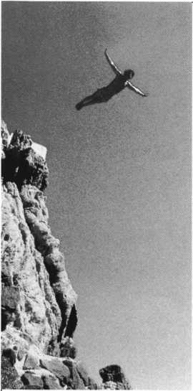

Has this  
lost his  
or what?

guy

mind

Ko sunscreen.

Over a lifetime, one in five Americans will develop skin cancer. Don’t be the one. Tor more information, see your dermatologist.



www•aad.org

**401**

***Keynotes***

November **1999**

Scholarships are awarded to those individuals who demonstrate their financial need and their desire for more education in the locksmithing field. If you or someone you know fits the above criteria, please fill out the application on this page and send or fax to the ALOA Office at 3003 Live Oak St., Dallas, Texas 75204 by the due date on February 1, 2000. The fax number is (214) 827-1810. Don’t forget to include your letter stating your reason for applying, your three letters of reference and your financial information. No late or incomplete applications will be considered.

ALOA SCHOLARSHIP FOUNDATION, INC.

ALOA/SAVTA SCHOLARSHIP APPLICATION  
3003 Live Oak Street; Dallas TX 75204; (214) 827-1701

Please print or type

NAME PRP LEVEL ALOA/SAVTA# HOME ADDRESS CITY STATE ZIP

HOME PHONE- DOB // EDUCATIONAL LEVEL [YEARS] DEGREE, IF ANY

PRESENT EMPLOYER WORK PHONE- FAX -

WORK ADDRESS CITY STATE ZIP  
POSITION □ FULL TIME □ PART TIME TAKE HOME PAY $

LENGTH OF TIME IN LOCKSMITHING OWNER/SUPERVISOR’S FULL NAME  
MEMBERSHIP IN TRADE ASSOCIATIONS (LIST BY NAME)

MARITAL STATUS SPOUSE’S OCCUPATION SPOUSE’S TAKE HOME PAY $

COMBINED HOUSEHOLD ADJUSTED GROSS INCOME $ NUMBER OF DEPENDENTS

CLASSES DESIRED DATE OF CLASSES //

ORGANIZATION SPONSORING CLASSES: □ ALOA □ SAVTA □ OTHER (PLEASE NAME)

LO C ATI 0 N

ALOA Scholarships are granted to selected individuals desirous of entering the locksmithing field or to selected individuals already in the locksmithing field who wish to improve their professional skills through education.

Applications for classes being taken locally must be received a minimum of 60 days prior to the date of the class, and will be reviewed as they are submitted. Scholarships for classes at the ALOA or SAVTA convention will be awarded each year at the ALOA Scholarship Foundation meeting preceding the convention and must be received by February 1 each year.

Please attach to this form a letter stating your reason for applying for a scholarship, what you plan to do with the knowledge you obtain and any other information you feel may be helpful to the scholarship board in making its decision. In addition, attach three let­ters of reference from individuals who have personal knowledge of your background and character. The letters should contain their names, addresses and phone numbers. It would be helpful if at least one of these references is an ALOA or SAVTA member. Also, please provide a copy of your most recent tax return.

All scholarship recipients will be required to provide a 3x5 inch photograph of themselves.

APPLICATION CHECK LIST

Only complete applications will be considered for scholarships. An application is considered incomplete unless ALL of the above requested information is received before the deadline: 60 days prior to the date of a class or February 1 for ALOA/SAVTA convention classes. Please send this application after checking off each of the below.

* I have filled in each blank on this form.
* I have written and enclosed a letter explaining my reason for applying.
* I have enclosed three letters of reference.
* I have enclosed a copy of my most recent tax return.
* I am submitting this in time to be received 60 days prior to the date of a class or by February 1 for ALOA/SAVTA convention classes.

CERTIFICATION OF APPLICANT:

I certify that the information contained herein, and all supplemental forms are complete and correct to the best of my knowledge. I further certify that if I am selected as a scholarship recipient I will use the knowledge gained for the improvement, development and advancement of the locksmithing profession.

Signature Date//

11/99

**November 1999** **Keynotes**

Keynotes

Authors



Dept

Donald B. Dennis, CPL has been dealing with the Locksmithing profession since 1972 with a four year apprenticeship in Albuquerque, New Mexico. He founded and has been the owner of Dennis Safe & Lock in Johnson City, Tennessee since 1977. He

was the founder of the East Tennessee Locksmith Association in 1988 and is currently the Chairman of the Education Committee and editor ofETLA Newsletter.

Marray Introduces... Factory Direct Prices

Electrified

Locks...as low as $142.00  
Hinges...as low as $64.80  
Panic bars...as low as $193.05  
Trim...as low as $270.00

WOW!!

Best Price Guaranteed!

What are you waiting for?

Call Marray Today  
1-800-500-1449

Marray. Your first source for UL listed & modified hardware.



Marray *enterprises, inc.*

At Marray, we’re not just modifiers, we’re Master Hardware Modifiers™  
1128 Walsh Ave., Santa Clara, CA 95050. [www.marray.com](http://www.marray.com)

VISA, MASTERCARD, COD. OPEN ACCOUNTS A.O.C.



. Claire L. Cohen, the second

woman to become a CML, has been in locksmithing  
since 1977 and has been writing articles for  
Keynotes since 1987. She is also a contributing  
editor for Keynotes.

I Sal Dulcamaro, CML, has been in

the locksmith business for over 24 years. He is the  
president of All Pro Security, Inc. in Michigan and  
has been an ALOA member for 17 years. A past  
president of the Locksmith Security Association of  
Michigan. Sal currently serves as editor of the  
association newsletter. He was named "Keynotes  
Author of the YeaP’ for 1996 and 1997. He is also  
a contributing editor for Keynotes.

Mike Eerrill is a third generation

locksmith, who lives on the Island of Nantucket in  
Massachusetts.

C.D. Lipscomb, CML, CPS lives

in Corsicana, Texas and operates Navco Safe and  
Lock Co. He has been serving the public as a  
locksmith for 25 years. He is a member of ALOA,  
SAVTA, Greater Dallas Locksmith Association,  
Texas Locksmith Association, Metroplex Locksmith  
Association, The Oklahoma Master Locksmith  
Association and is a charter member of the Clearstar  
Online Locksmith Association. He has been awarded  
a Life membership in the Greater Dallas Locksmith  
Association for outstanding service.



Tim McMullen oversees legislative

affairs for ALOA. He is a graduate of the District  
of Columbia School of Law and has an extensive  
background in legislative work.

Keynotes

November 1999

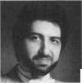

VISA

'f,. **AT HA** r‘ lOIBII

SsCARD



*mam*



Diners Club International*

Accept Credit Cards  
and Increase Sales and Profits  
by 30% - 50%

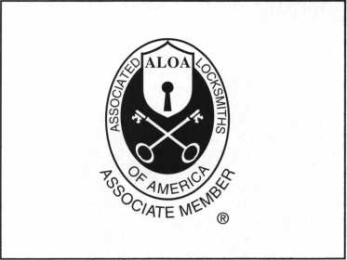

There are three reasons why people don’t accept credit cards:

Through Association Benefits **^** 1. Too expensive.

These Concerns Are Eliminated 2. The paperwork hassle.

3. Inability to qualify.

Here’s how it works:

* Simply swipe or enter the credit card #.
* Enter amount of sale. Xo Hassle - EOSX Qualifying
* Approval within seconds.
* Funds wired electronically into your local checking account within 48 hours.

Because of your association membership, nearly 100% of all retail and home based applicants

will be approved even with past credit problems.

Currently Processing Merchants Please Read

Monthly Lease To Own Set-Up Options

Special Low Discount Rate and Transaction Fee: 1.59% + 201

Plus Monthly Statement!Customer Service Fee: $10

Package A: $29.95 Terminal

Package B: $39.95 Terminal & Printer In One

Deluxe Package C: $49.95 Portable Terminal/Printer/Pin Pad  
Debit acess fee Ability to Accept Visa/MC “Check Cards”

$ 10/mo. & ATM caj-ds at a FLAT 250

Totally Eliminating the 1.59 % Rate  
(All lease terms 48 months • Monthly minimum $25)

I authorize Universal’s sales office to print and deposit a check  
in the amount of $49 (normally $125) for my application fee which

covers initial materials, application processing, equipment warranty,

shipping & handling, programming, installation and training.

* Fill out a check, tape here above mini form and then fax.

Fax Express Mini Form Now To **1 -800-439-7773**

^epr°9^

You0!**

“ Pay OMy^glsproces, nnr

fte ^ ^ flat

Per

59%;r,cu^«fc- ■■ dacccpi^%

debit ^a*dVaaces

!OVV.)

Company Name. Contact Name

Address. City

State-

Zip.

Phone

Best Time

Signature.

New Account Set-up Options (Check)

Package A □

Package B □

Deluxe Package C I—I

Free Pin Pad Program For Currently Processing Merchants □

A subsidiary of Universal Savings Bank, F.A.

Marketing Office *1-800-836-4295*

Universal Payment Processing Provides 24 Hour Live Customer Service.

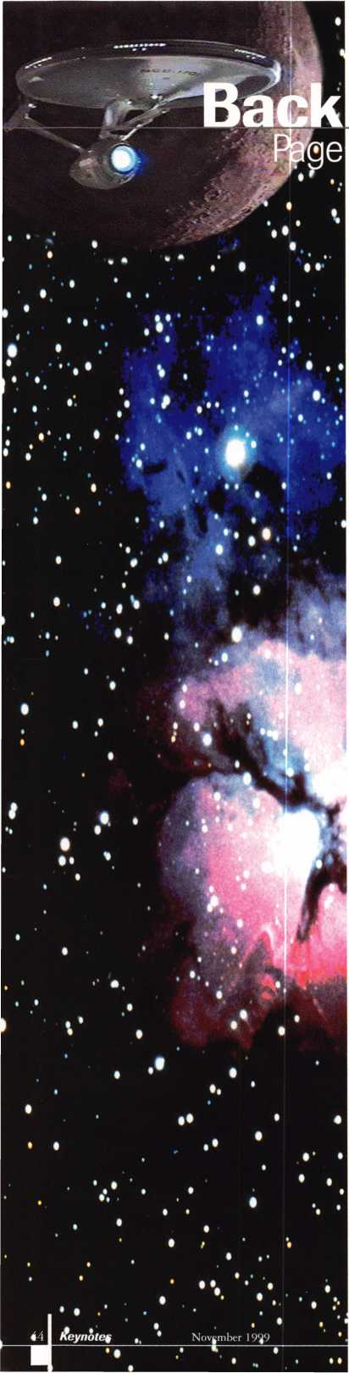

Las Vegas...the Final Frontier.

ALOA 2000 will be held at the Las Vegas Convention Center, the perfect place  
to kick off a new century of Security Expos and Conventions. Near to the Convention  
Center is the Las Vegas Hilton, home to Star Trek: The Experience, an interactive area  
where everyone can visit the 23rd century and its intergalactic inhabitants.

Its a must-see for Trekkies and a treat for neophytes to the phenomenal television  
series. So, to test your knowledge of the Starship Enterprise and its crew, here’s a quiz  
to prime you for next summer’s convention.

We’ll draw one lucky winner from everyone who sends in correct answers. Once  
selected, that person will receive a very special prize!

1. As James T. Kirk, the often over-dramatic William Shatner portrayed  
   the original series’ leading man. What does the T. stand for in his name?
2. Some people call him a mere robot, but Data on Star Trek: The Next Generation  
   is actually a what?
3. Name the famous president that Captain Kirk idolized and once met.
4. Mr. Spock is a:
5. Klingon
6. Betazoid
7. Horta
8. Vulcan
9. Before Captain Kirk assumed command of the Starship Enterprise,  
   who was its captain?

Send your answers to:

ALOA’s Star Trek Quiz:

3003 Live Oak  
Dallas, TX 75204

Fax: 214.8271810

Email: [keynotes@anet-dfw.com](mailto:keynotes@anet-dfw.com)

extend my subscription to Locksmith Ledger International

Please

ns

I

**ne f<ir the Security Professional**

OrLNING  
A **WORLD Or  
OrrORTUNITILS**

□ 3 YEARS (includes 36 issues, 3 FREE Annual Directory* issues)

USA $90.00

J 2 YEARS (includes 24 issues, 2 FREE Annual Directory* issues)

USA $64.00 Canada $93.00 International (air) $185.00

J 1 YEAR (includes 12 issues, 1 FREE Annual Directory* issue)

USA $41.00 Canada $52.00 International (air) $100.00

International (surface) $119.00

International (surface) $65.00

’Comprehensive guide to industry manufacturers, distributors, products and services.

CARD INVALID UNLESS COMPLETE DATA IS GIVEN

You must indicate your locksmithing affiliation below:

1. Are you a locksmith or an individual involved in locksmithing? Qyes Qno
2. Your position is: QOwner/Pres. Q3 Employee Q6 Student Q9 Other (specify)

3 Business classification (check one only): a □Locksmith Shop b □ Hardware c Q Wholesaler/Distributor d Q Manufacturer e Q Security or Maintenance

1Q Consultant 3 Q Industrial sQ Government

2 Q Commercial 4 Q Institutional 6 Q Police

g Q Architect/Specifier z Q Other (specify)

4. Are you involved in purchasing or influencing the purchase of locksmith products?

□yes Qno

Name:.

Company:. Address: _

City:.

. State:.

-Zip:_

Phone: _

.Fax: _

Payment (US FUNDS ONLY): □Money order □Charge Card □Check#:

Complete For Charge Orders Only: QVISA □ Master Card QAmerican Express  
Account # :Exp. Date:

Signature:

IM9

Send payment to: Locksmith Publishing Corp. • 850BusseHwy. • Park Ridge, IL 60068 • Phone:(847)692-5940 • Fax (847) 692-4604 • Website: [www.lpc.simon-net.com](http://www.lpc.simon-net.com)

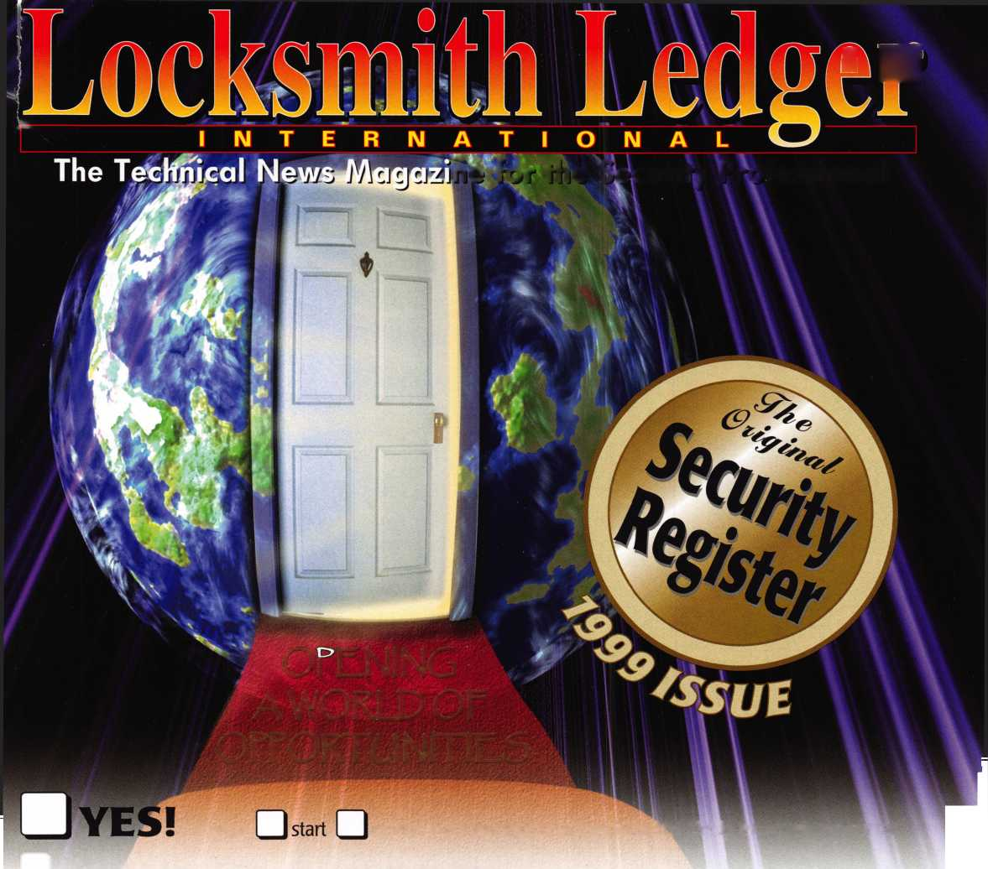

know



To navigate your locksmithing enterprise into the next millennium you need the latest training, product information, and tools. You can explore the entire locksmithing universe at one great show—ALOA 2000 in Las Vegas, Nevada.

You can also beam aboard the Las Vegas Hilton's newest attraction— Star Trek: The Experience. For more information visit our website at http:/ / [www.aloa.org/](http://www.aloa.org/) and plan to boldly go to ALOA 2000.

